Project ID: 924



**Coordination of Care Service Functional Model, Release 1**

May 2014

**HL7 Draft Standard for Trial Use (DSTU) Ballot**

**Sponsored by:  
Patient Care Workgroup**

**Service Oriented Architecture Workgroup**

**Additional Interested Work Group Name:**

**Clinical Decision Support Workgroup**

Copyright © 2013 Health Level Seven International ® ALL RIGHTS RESERVED. The reproduction of this material in any form is strictly forbidden without the written permission of the publisher. HL7 and Health Level Seven are registered trademarks of Health Level Seven International. Reg. U.S. Pat & TM Off**.**

Use of this material is governed by HL7's [**IP Compliance Policy**](http://www.hl7.org/legal/ippolicy.cfm?ref=nav).

## Note to Readers

This document describes the Service Functional Model (SFM) for the HL7 Coordination of Care Services Specification, which is specified under the Service Development Framework process under the auspices of the Healthcare Services Specification Project (HSSP). Further context is given in the overview section below, but one key point to note is that the SFM provides a Service **Interface** specification, NOT the specification of a technical Service platform specific implementation. This is a critical distinction in terms of Service Oriented Architecture. There could be different ways of implementing all or part of the functionality to support the behavior described in this specification.

## Change History

|  |  |  |  |
| --- | --- | --- | --- |
| Version | Date | Author | Changes |
| 0.5 | March 17th, 2013 | Jon Farmer,  Enrique Meneses | Draft for comments and community feedback – HL7 May 2013 ballot cycle |
| 1.0 | March 23rd, 2014 | Enrique Meneses  Stephen Chu MD PhD  Laura Heerman Langford PhD RN | Many updates based on ballot comments, community feedback and workgroup meetings.  DSTU – Draft Standard for Trial Use – HL7 May 2014 ballot cycle |
| 1.1 | February 3rd, 2014 | Enrique Meneses  Emma Jones | Updates based on DSTU comments |

## Project Coordinator and Document Editors

Enrique Meneses

Stephen Chu, MD, PhD

Laura Heermann Langford, PhD RN

## Collaborators and Contributors

Russell Leftwich, MD

Iona Thraen, PhD, MSW

Susan Campbell, PhD, RN

Lisa R Nelson, MS, MBA

Emma Jones, RN, MS

Randy Belknap

Nan Hou, PhD, RN

Kevin Coonan, MD

Jon Farmer

Ken Rubin

Chris White

Les Morgan

## Project Sponsors

HL7 Patient Care Work Group - <http://wiki.hl7.org/index.php?title=Patient_Care>

HL7 Care Plan Project - <http://wiki.hl7.org/index.php?title=Care_Plan_Project>

HL7 Service Oriented Architecture Work Group - <http://hssp.wikispaces.com>

# 

# Table of Contents

Note to Readers 3

Change History 3

Project Coordinator and Document Editors 4

Collaborators and Contributors 4

Project Sponsors 4

Table of Contents 0

Preface 2

HL7-OMG Healthcare Services Specification Project (HSSP) 2

Service Definition Principles 3

Overall disclaimers 3

Readers Guide 4

1. Executive Summary 5

Background1 5

Project Overview 7

Project Goals 8

Assumptions 8

Scope of Service Functional Model 8

Out of Scope for the Service Functional Model 9

Significant Terms 9

2. Business Story Boards 12

Storyboard 1 12

Storyboard 2 13

Storyboard 3 13

Storyboard 4 14

Storyboard 5 15

3. Care Team Interaction Illustrations 20

4. Service Functional Model 24

Care Team Membership Capabilities 26

Care Team Communication Capabilities 32

Care Team Availability/Scheduling Capabilities 37

Care Plan Management Capabilities 38

Plan Templates 47

Plan Resource Support Capabilities 48

Progress and Outcome Review Capabilities 50

Observations and Supportive Content Capabilities 52

Reconciliation Process Support 54

5. Profile Grouping 56

Care Team Communication 56

Care Planning and Execution – Dynamic Care Team Contribution 56

Clinical Decision Support (CDS) 57

Plan Content Publishing 57

Appendix A - Relevant Standards 58

Appendix B – Relationship to Information Content 59

# Preface

The Service Specification Development Framework Methodology is the methodology followed to define HSSP specifications. The methodology sets out an overall process and defines the responsibilities of the Service Functional Model (SFM). Section 2 sets out the business context for this particular specification, but first it is important to understand the overall context within which this specification is written, i.e. its purpose from a methodology standpoint.

## HL7-OMG Healthcare Services Specification Project (HSSP)

The Healthcare Services Specification Project (HSSP) [[http://hssp.wikispaces.com](http://hssp.wikispaces.com/)] is a joint endeavor between Health Level Seven (HL7) [<http://www.hl7.org>] and the Object Management Group (OMG) [<http://www.omg.org>]. The HSSP was chartered at the January 2005 HL7 meeting under the Electronic Health Records Technical Committee, and the project was subsequently validated by the Board of Directors of both organizations.

The HSSP has several objectives. These objectives include the following:

* To stimulate the adoption and use of standardized “plug-and-play” services by healthcare software product vendors
* To facilitate the development of a set of implementable interface standards supporting agreed-upon services specifications to form the basis for provider purchasing and procurement decisions.
* To complement and not conflict with existing HL7 work products and activities, leveraging content and lessons learned from elsewhere within the organization.

Within the process, HL7 has primary responsibility for:

* Identifying and prioritizing services as candidates for standardization
* Specifying the functional requirements and conformance criteria for these services in the form of Service Functional Model (SFM) specifications such as this document
* Adopting these SFMs as balloted HL7 standards.

These activities are coordinated by the HL7 Services Oriented Architecture WG in collaboration with other HL7 committees. For this DSTU, the Coordination of Care Service Specification Project is sponsored by the HL7 Patient Care Working Group in close collaboration with the Care Plan project which is leading in the specification of the clinical domain models [<http://wiki.hl7.org/index.php?title=Care_Plan_Project>].

Based on the HL7 SFMs, OMG will develop “Requests for Proposals” (RFPs) that are the basis of the OMG standardization process. This process allows vendors and other submitters to propose solutions that satisfy the mandatory and optional requirements expressed in the RFP while leaving design flexibility to the submitters and implementation flexibility to the users of the standard. The result of this collaboration is an RFP Submission, which will be referred to in the HSSP process as a Service Technical Model (STM). HL7 members, content, and concerns are integral to this process, and will be explicitly included in the RFP creation and evaluation process.

It is important to note that the HL7 SFMs specify the *functional* requirements of a service, the OMG RFPs specify the *technical* requirements of a service, and the STM represents the resulting technical model, except as specified below. In many cases, SFMs describe an overall coherent set of functional capabilities and / or define a minimum set of behaviors necessary to guarantee a minimal level of service in a deployment scenario. These capabilities may be specialized or subdivided from both functional and informational (semantic) perspectives to provide conformance “profiles” that may be used as the basis for the OMG RFP process and/or implemented.

## Service Definition Principles

The high level principles regarding service definition that have been adopted by the Services Specification Project are as follows:

* Service Specifications shall be well defined and clearly scoped and with well understood requirements and responsibilities.
* Services should have a unity of purpose (e.g., fulfilling one domain or area) but services themselves may be composable.
* Services will be specified sufficiently to address functional, semantic, and structural interoperability.
* It must be possible to replace one conformant service implementation with another meeting the same service specification while maintaining functionality of the system.

A Service at the SFM level is regarded as a system component; the meaning of the term “(system) component” in this context is consistent with UML usage[1]. A component is a modular unit with well-defined interfaces that is replaceable within its environment. A component can always be considered an autonomous unit within a system or subsystem. It has one or more provided and/or required interfaces, and its internals are hidden and inaccessible other than as provided by its interfaces.

Each Service’s Functional Model defines the interfaces that the service exposes to its environment, and the service’s dependencies on services provided by other components in its environment. Dependencies in the Functional Model relate to services that have or may in future have a Functional Model at a similar level; detail dependencies on low-level utility services should not be included, as that level of design is not in scope for the Functional Model.

The manner in which services and interfaces are deployed, discovered, and so forth is outside the scope of the Functional Model. However, HSSP Functional Models may reference content from other areas of HSSP work that deals with architecture, deployment, naming and so forth. Except where explicitly specified, these references are to be considered informative only. All other interactions within the scope of the scenarios identified above are in the scope of the Functional Model.

Reference may be made to other specifications for interface descriptions, for example where an interface is governed by an existing standard.

## Overall disclaimers

* Examples are illustrative and not normative unless otherwise specified
* The scope of information content of HSSP service specifications is not limited to HL7 content models. At a minimum, however, specifications should provide a semantic profile as part of its conformance profile to provide support for HL7 content models where applicable.

## Readers Guide

Based upon the nature of your interest, we suggest the following as areas to focus your attention:

|  |  |
| --- | --- |
| Audience | Sections (In order of priority) |
| Domain Committees, SME’s | 1, 2, 3, 4 |
| Architects, HSSP | 1, 3, 4 |
| RFP Submitters | 1, 5, 4, 3 |

# Executive Summary

## Background1

The World Health Organization (WHO) defines chronic diseases as “diseases that are of long duration and generally slow progression (<http://www.who.int/topics/chronic_diseases/en/>)” and can have long-term effects. “Chronic” is usually applied to diseases lasting over 3 months (World Health Organization). Individuals of all ages are living longer with chronic illness and disability. The World Health Organization[2] estimates 63% of all annual deaths (~36 million people) are attributable to non-communicable or chronic diseases. As the number and complexity of health conditions increase over time and episodes of acute illness are superimposed, the number of care providers contributing to individual care increases as well. With this complexity, it becomes significantly more difficult to align and coordinate care among diverse providers who frequently span multiple sites.

The numbers of health care service delivery encounters required by individuals, as well as the failure to deliver and coordinate needed services are significant sources of frustration and errors and are drivers of health care expenditures. According to claims data reported for US Medicare beneficiaries in 2003-2004, 19.6% of re-hospitalizations occurred 30 days after discharge. This translated into $17.4 billion dollars in hospital payments from Medicare in 20043. Providing person-centered care is particularly important for medically-complex and/or functionally impaired individuals given the complexity, range, and on-going and evolving nature of their health status and the services needed. Effective, collaborative partnerships between service providers and individuals are necessary to ensure that individuals have the ability to participate in planning their care and that their wants, needs, and preferences are respected in health care decision making.

The ability to target appropriate services and to coordinate care over time, across multiple clinicians and sites of service, with the engagement of the individual (i.e. longitudinal coordination of care) is essential to alleviating fragmented, duplicative and costly care for these medically complex and/or functionally impaired persons.

Efficient health information exchange to support coordination of care across multiple clinicians and care sites requires more than medication reconciliation and care summary exchanges. The availability and adoption of standards to support and inform care delivery independent of care setting is essential to alleviating fragmented, duplicative and costly care.

Without a process to reconcile potentially conflicting plans created by multiple providers, it is difficult, if not impossible to avoid unnecessary and potentially harmful interventions. Without such a process, it is also difficult to shift the perspective of providers from the management of currently active issues to consideration of future goals and expectations. Similarly, the challenge of establishing a consensus driven process across multiple disciplines and settings is confounded by a fragmented system of policies, technologies and services.

As information moves across settings in the longitudinal care space, care team members need more information than standard chart summaries typically provide. Care team members, including patients, benefit from sharing comprehensive patient data and information, including the care plan. In addition, the contributions of the care team to this information needs to be current for all stakeholders as it changes in order to avoid communication gaps and conflicting interventions.

There is growing recognition of the need for and benefits of fully interoperable Health Information Technology (HIT) capabilities across care provider groups. Of importance are the information or data needs of the medically complex and/or functionally impaired individuals. Effective, collaborative partnerships among service providers and individuals are necessary to ensure that individuals have the ability to participate in planning their care and that their wants, needs, and preferences are respected in health care decision making4.

The identification and harmonization of standards for the longitudinal coordination of care will improve efficiencies and promote collaboration by:

* Improving provider’s workflow by enabling secure, single-point data entry for data related to care coordination
* Eliminating the large amount of time wasted in phone communication and the frustrations on the side of the receiving provider in not always obtaining care transition and care planning information in a timely manner
* Reducing paper and fax, and corresponding manual processes during care coordination
* Supporting the timely transition of relevant clinical information at each point of care transition and as the patient’s condition changes
* Enabling sending and receiving provider groups to initiate and/or recommend changes to patient interventions more promptly

# 2 Project Overview

The scope of this specification is to define the functions or capabilities required for effective coordination of care systems. It includes illustrative story boards and care team collaboration illustrative models. This service functional model (SFM) will define the scope of the requirements for a subsequent phase of the project which will define a technical services specification. The service capabilities define the functions and may not map to a technical service operation with a 1-to-1 relationship.

Development of the *HL7 Coordination of Care SFM* is guided by the following principles:

* Ongoing coordination of care is a collaborative activity between *care team* members
* The patient and designated family care givers are members of the *Care Team*
* Effective coordination of care requires a systems engineering perspective which considers all the parts of the (eco)system:
  + Care Team collaboration
  + Goal oriented care planning
  + Tracking care activities and interventions
  + Continual Assessment and Review
  + Clinical domain/specialty and care setting context

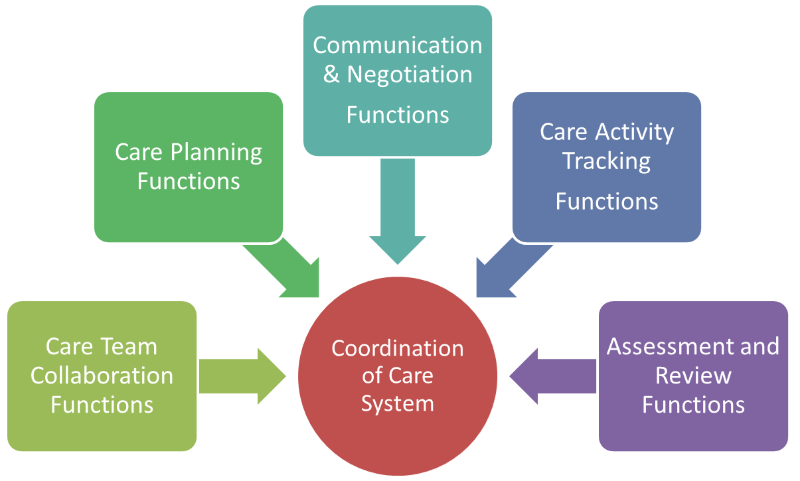

Figure 1 - Coordination of Care Service Functions

## 2.1 Project Goals

* Identify domain functions or capabilities to support dynamic, evolving and ongoing clinical care and the coordination of that care, with the following understanding about the identified capabilities:
  + The capabilities represent individual building blocks and do not express how they form the bigger story of care coordination.
  + The capabilities support an emergent and dynamic process resulting from care team interactions
* Illustrate how the capabilities support dynamic coordination of care interactions
* Specify requirements necessary to support health care systems which incorporate dynamic and ongoing contributions of care team members in order to reduce gaps in communication, such as:
  + Missing or late change updates
  + Incorporation of critical new information
  + Conflicting or redundant care strategies
* Support a connected care team with a shared perspective of a coordinated care plan

## 2.2 Assumptions

* Familiarity with the HL7 Care Plan Domain Analysis model and related HL7 Patient Care Workgroup artefacts.

## 2.3 Scope of Service Functional Model

* Identify Coordination of Care Service domain capabilities (Normative for DSTU)
  + The capabilities express domain level business functions
  + The capabilities do not describe a technical specification
  + The capabilities define the “what” but not the “how” of coordination of care
* Illustrative clinical story boards.
* Illustrate a pattern for use of the capabilities (Non-Normative for DSTU)
  + The patterns define the elements of a process and how the individual capabilities (building block functions) fit with in an overall dynamic, changing and evolving process among care team members coordinating care across care settings.

## 2.4 Out of Scope for the Service Functional Model

* Definition of any new domain information models. The scope of the domain is based on work done by the HL7 Patient Care work group (specially the Care Plan Project).
* Governance, organization policies and business rules
  + All mentions of individual professions and interactions are illustrative only. They are not meant to exclude a given group. Examples are not meant to favor or prescribe a specific approach to coordination of care.

## 2.5 Significant Terms

The following table summarizes significant terms required in order to understand the service functional model. For a complete presentation of these terms please refer to the PCWG Care Plan Domain Analysis Model.

#### 2.5.1 Care Plan Domain Terms

|  |  |
| --- | --- |
| **Term/Concept** | **Description** |
| **Plan** | The concept “plan” is used synonymously with “care plan” in its generic sense. Refer to Care Plan DAM for a description of “care plan”. |
| **Health Concern** | A Health Concern is a health related matter that is of interest, importance or worry to someone, who may be the patient, patient's family or patient's health care provider.  (<http://wiki.hl7.org/index.php?title=Health_Concern>)  Health concerns specify the condition oriented reasons for creating the plan |
| **Health Goal** | A desired outcome attached to patient health problems and plans (adapted from HL7 RIM Mood Code: Goal)  A Health Goal may be composed of finer grained intermediary milestones |
| **Health Risk** | A factor (including lifestyle, environmental, family or genetic in nature) or activity that may adversely affect the health or wellbeing of an individual.  A plan may capture a patient’s inherent health risks or risks that may be associated with certain interventions, so that there can be awareness among the care team as they monitor any impact on the patient’s health which may introduce new health concerns based on the risk |
| **Care Barrier** | A care barrier presents a situation which impacts progression of the identified health goals by blocking specific interventions or activities. Interventions and other plan activities may be modified in order to remove the block. |
| **Patient Preference** | A care preference is a statement expressed by the patient, custodian or caretaker responsible for the patient in order to influence how their care is delivered. Care preferences express patient desires of how they want to be treated or their choice(s) of intervention/care activity. |
| **Acceptance Review** | In the context of care plan, acceptance review is assessment/appraisal or evaluation of relevant care plan components/activities (e.g. health concern, health goal, health risk, intervention) with the intention of accepting or changing one or more of these components.  An AcceptanceReview captures the care team’s (including patient) agreement with the health goals of the plan.  It may also capture disagreement or compromises between care team members regarding what the goal should be. Capturing varying perspectives facilitates harmonization of the health goals in dynamic care plan applications |
| **Plan Review** | The assessment/appraisal or evaluation of the overall care plan with the intention of changing or closing the care plan. |
| **Communication** | The imparting or exchanging of information (Adapted from: http://www.merriam-webster.com) |
| **Negotiation** | A process, formal discussion or exchange between people who are trying to reach an agreement. (Adapted from: http://www.merriam-webster.com) |

#### 2.5.2 Reconciliation[3]:

Reconciliation (as applied to health care information) is the process of merging and adjudicating conflicts between health care information obtained from multiple sources. The sources of information can be electronic and/or paper-based. The reconciliation process typically occurs during transfers or transitions of care from one healthcare practice setting or level of care to another, and can occur at other times as needed. Some examples of the type of information that may be reconciled include: medical history (diagnosis, problems), medications, allergy/intolerance, care strategies and the patient’s care plan. Other information of administrative, social services and financial nature such as payor and insurance coverage data may also be included.

##### 2.5.2.1 Components of Reconciliation:

**Technical**: the process of procuring and merging clinical information from multiple sources. The technical component typically involves sending query requests to clinical information systems or electronic health record repositories and merging the records returned from multiple repositories. The query parameters can be predetermined or defined at runtime by clinical users based on characteristics or profile of the patient. The technical reconciliation process also involves validation and highlighting of patient identification, electronic identification of duplicates, overlaps, conflicts and superseded information to facilitate clinical reconciliation.

**Clinical**: the process of adjudicating conflicts between clinical information obtained from multiple sources by clinicians. The adjudication may involve/include: resolving ambiguities, duplications, inconsistencies, contradictions, errors and omissions. Additional adjudication may need to occur in light of patient preferences, clinical status changes, current governance, or national, state and organizational regulations and policies. This requires the comparison and evaluation of information obtained from multiple sources and validation with the patient and/or authorized patient representatives, prescribers and dispensers.

The clinician corrects, updates, and confirms the reconciled information; and highlight issues that need clinical attention.

**Harmonization**: is the process of bringing into or coming to agreement, harmony or accord.

It involves adjustment of differences in information, measurements, methods, schedules or specifications to make them uniform or mutually compatible. Harmonization is considered synonymous with reconciliation[4].

**Synchronization** (in computing):

The process of making two or more data stores, devices, programs or systems to have exactly the same information and behavior, or be coherent with each other at a given time.

# Business Story Boards

Care Plan Reconciliation/Harmonization:

May be applied to

* Health Concern/Problem
* Health Goal
* Health Risk
* Care Preference
* Care Barrier
* Activity/intervention

## 3.1 Storyboard 1

A 76-year old patient had total hip replacement. On Day 5 post-op the patient was discharged back to aged care facility for continuous long term care. Included in the hospital discharge document is an orthopaedic care plan developed by the patient’s orthopaedic surgeon. The patient’s attending Provider (PCP) has developed a post total hip replacement care plan for the patient.

The clinical information system (CIS) of the aged care facility initiated a Plan ***synchronization*** process that brought the contents of the orthopaedic care plan into the care plan such that the synchronized care plan contains the information of both plans.

In this example, the decision support application of the CIS also initiated a ***technical reconciliation*** process which identified conflicts in the rehabilitation activity orders between the PCP care plan and orthopaedic care plan:

Care Plan – standing orders include the following activities

* Attend daily physiotherapy session
* Transfer from bed to chair independently
* Weight bearing as tolerated
* Walk to bathroom and hallway using walking frame

Orthopaedic care plan –

Day 6

Continue exercises in bed (3-4 sessions each day): bed support knee-bends, buttock contractions, abduction exercises, quadriceps exercises, straight leg rising

Day 7

Standing exercises (3-4 sessions each day): standing knee raises, standing hip abduction, standing hip extension

From Day 8:

Transfer from bed to chair independently

Walking using walking frame

Gradual increase weight bearing as tolerated

The CIS highlighted the inconsistencies in the rehabilitation activity order between the two Plans and brought to the attention of the PCP

The PCP conducted a review of the two plans, initiated a review conversation with the patient’s orthopaedic surgeon; and noted that the reasons for a slower rehabilitation schedule were due to the surgical (incision) approach, condition of the patient’s hip joint, and mild neuromuscular weakness/problem

The PCP initiated a ***clinical reconciliation*** process and harmonized the care plan to adopt the rehabilitation schedule prescribed in the orthopaedic care plan

## 3.2 Storyboard 2

A 70 year old Retirement home resident with a medical history of type 2 DM and hypertension was admitted to the hospital with sudden onset of right-sided weakness and right facial droop, dysarthria, and slight confusion. CT of the brain indicated a thrombus in a branch of the left internal carotid artery, with approximately 50% occlusion due to atherosclerosis. There was an area of infarction in the right anterior hemisphere. There was no evidence of a subarachnoid haemorrhage. Speech pathologist assessment placed the patient on aspiration alert. The hospital dietitian/nutritionist recommended vitamised diet

The patient’s hypertension/CVS and Diabetes care plan was sent by the patient’s PCP. The care plan recorded counseling on dietary changes (including increased consumption of fresh fruit and vegetables, low-fat dairy products, omega-3 fatty acids; reduction of saturated fat intake, trans-fatty acids, and cholesterol; sodium restriction).

The hospital CIS initiated a ***Plan synchronization*** process which synchronized relevant contents of the PCP care plan into the hospital Stroke care plan

The decision support application of CIS also initiated a ***technical reconciliation*** process which identified conflicts between the nutrition components of the two Plans

The CIS highlighted the conflicts and brought them to the attention of the hospital dietitian.

The hospital dietitian initiated a clinical review of the contents of the plans. ***Clinical reconciliation*** conducted by the dietitian resulted in overriding the diet order in the PCP care plan.

## 3.3 Storyboard 3

A female patient has medical history of rheumatoid arthritis diagnosed when she was 46 years of age. She was treated by her rheumatologist during episodes of acute exacerbation, but otherwise her rheumatoid arthritis was managed by her Primary Care Provider (PCP).

The rheumatoid arthritis care plan developed by her PCP included the following medication treatment:

* Selective cox-2 inhibitor: celecoxib
* Corticosteroid
* Disease modifying anti-rheumatic drugs: methotrexate
* Supplements: vitamin D and calcium

At age 52 the patient was diagnosed with Type 2 Diabetes Mellitus. The patient’s blood lipid profile also confirmed hyperlipidaemia.

The patient’s PCP initiated a Diabetes care plan after discussions with the patient.

The CIS used by the PCP initiated a ***Plan* *synchronization*** process which synchronized the medication interventions of both the rheumatoid arthritis and diabetes care plans.

The decision support application of CIS may also initiate a decision logic evaluation of potential health risks of anti-rheumatoid medication therapy to this patient.

The CIS highlighted the selective Cox-2 inhibitor as a cardiovascular risk factor for patient with diabetes and hyperlipidaemia

The PCP initiated a clinical review of the anti-rheumatoid medication therapy, initiated a review conversation with the patient’s rheumatologist to discuss the anti-rheumatoid medication therapy and how best to mitigate the associated cardiovascular risks.

Following discussion with the rheumatologist, the PCP initiated a ***clinical reconciliation*** process and changed the selective Cox-2 inhibitor to acetaminophen/paracetamol and a weak opiate (codeine)

## 3.4 Storyboard 4[5]

**Background**

A 78 year old female patient suffering from congestive heart failure and atrial fibrillation was discharged from hospital to a skilled nursing facility before blood test for drug (digoxin) level was available to the discharging physician. Her discharge medications included amiordarone and lanoxin.

A physician on-call at the skilled nursing facility was requested to add digoxin to the prescribed medication list at the insistence of the patient. A pharmacy technician was told not to question physician order when attempted to raise question on the new digoxin prescription on existing lanoxin prescription.

Three days after admission to the skilled nursing facility, the patient started to exhibit signs and symptoms of toxicity.

A week later, patient showed full features of digitalis toxicity. Blood test showed serum digoxin level double the already high drug level on specimen taken at discharge from hospital.

The physician attending the nursing home patients conducted a review of the care plan and noted from the discharge plan that the patient was prescribed lanoxin and had pending serum digoxin test result.

The physician invoked the CCS communication function to find out from the discharging physician the result of the serum digoxin test.

The discharging physician responded via a message with the test result: serum digoxin level = 4.099 nmol/liter (3.2ng/L); [normal 1.2-2 nmol/L; 0.8-2ng/L]

The SNF physician explained to the patient that lanoxin is a brand named medication for the generic digoxin, and that her serum digoxin level was already too high.

The physician withheld the lanoxin for 2 days and ordered another blood test to be repeated after 2 days

The physician updated the patient’s medical record, medication chart and care plan.

The physician also communicated the revised treatment plan to the SNF nurse assigned to look after this patient.

## 3.5 Storyboard 5

**Care Coordination Environment – contribution, communication, negotiation, sharing and reconciliation/harmonization processes**

**Patient Background**

Adam Everyman is a 46 year-old male, married with 2 children. He was diagnosed as suffering from Type 2 diabetes, gastric ulcer, hyperlipidaemia and hypertension, ischaemic heart disease (with recurrent episodes of unstable angina) at age of 45. His height is 178cm (5’ 10”), weight is 97kg (213.5 lb) and BMI = 30 (Obese = 30+). He smokes 1 pack of cigarettes per day. He has a comprehensive care plan created by his Primary Care Physician (PCP), Dr Patricia Primary to manage his health problems.

In many instances the care plan is managed by a Care Coordinator. This role may be played by different members of the care team. In this story the patient’s primary care physician is serving as the Care Coordinator.

PCP care plan extract:

|  |  |  |
| --- | --- | --- |
| Health concerns | Health Goals | Action plan/Interventions |
| Poor blood glucose stabilization | Understand importance of blood glucose control  Achieve blood glucose control at levels between 8-10 mmol/L within 6 weeks  … | * Develop and implement blood glucose control education program with diabetes educator follow-up visits * Weekly patient- dietitian review meeting to plan realistic diabetic diet regime and implementation strategy * Diabetic medication prescription as per national guideline * Fortnightly patient-pharmacist medication review meetings to discuss diabetic medication management strategy * Implement BSL testing regime by patient |
| Difficulty with quitting smoking | ….. | ….. |
| Poor weight control | ….. | ….. |
| Difficulty on adhering to recommended diet | ….. | ….. |
| Poor blood cholesterol control | ….. | ….. |
| Poor blood pressure control | ….. | ….. |
| Difficulty with weight control | Reduce BMI to =<27 in 6 weeks  (reduce weight by 10kg) | * Develop and implement exercise program with exercise physiologist * Implement and adhere to diet program developed with dietitian |
| ….. | ….. | ….. |
| Inadequate health insurance cover | ….. | ….. |

**Knee Injury Event**

While Adam was on a skiing holiday with his family a week ago he slipped and fell on an icy path and seriously twisted both knees. He is seen at the local hospital ER and is referred to see an orthopaedic surgeon.

The referral notes from the patient’s PCS contain the following information:

* Patient’s past medical history: problem, diagnosis, previous procedure(s)
* Current complaint – knee injuries
* Allergy/intolerance list
* Relevant family history (e.g. mother had osteoarthritis of both knees from age of 50)
* Reason for referral
* Treatment at ER
  + Including list of known medications

The orthopaedic surgeon accepts the referral and informs the patient the first available appointment.

**Orthopaedic encounters**

The orthopaedic surgeon, Dr James Bone requested a number of imaging tests including ultra sound and MRI of the knees

The patient also informed Dr Bone that his other medical conditions are cared for by his GP who has established a care plan for better management of the health concerns

Dr Bone asks patient for consent to access his comprehensive care plan as information from the PCP care plan may have relevance/implications for the orthopaedic management strategies/plan

The patient provides the consent/access authorization as requested.

After evaluation of patient’s imaging results, clinical condition and various treatment options with the patient, Dr Bone recommended a treatment program and developed with the patient an initial orthopaedic care plan.

Dr Bone waits for access to the PCP care plan

**Care Plan Synchronization and Technical Reconciliation**

Dr Bone is soon given access to the comprehensive care plan by the PCP

The CIS from of the Orthopaedic Clinic initiated a plans **synchronization** process that imports the PCP care plan components into the orthopaedic care plan such that the orthopaedic care plan contains relevant components of both plans.

The CIS decision support (CDS) application performs a **technical reconciliation** which includes the following:

* Component by component comparative analysis of both plans:
  + Health concerns
  + Health goals
  + Action plan/interventions
  + Others, e.g. preferences, barriers
* Identifies the differences/conflicts in the two care plans:

Examples:

* The PCP care plan contains exercise programs for weight reduction but the orthopaedic care plan prescribes resting of the knees
* The CDS application also highlights the enhanced risks of cardiovascular event to this patient with medical history of unstable angina, which may be caused by the selective cox-2 inhibitor prescribed in the orthopaedic care plan

The orthopaedic surgeon is alerted to the conflicts identified

**Communications, Negotiations and Clinical Reconciliation**

The orthopaedic surgeon initiates communication and negotiation processes with the PCP and engages the patient and other relevant healthcare providers in the processes

The negotiation may include **proposals** (by the orthopaedic surgeon) to prioritize health concerns, prioritize/change health goals, prioritize or change action plan/interventions

The negotiation and outcome may also include **acceptance**, **rejection** with or without **counter** proposals (by the PCP, patient and/or other healthcare providers) to the proposals.

The negotiation and outcome may also include **acceptance/rejection with qualifier** (agree to disagree)

Example:

* Orthopaedic surgeon proposes surgical treatment (e.g. meniscectomy) to fix knee injury
* Patient disagrees and rejects surgical intervention proposal
* Orthopaedic surgeon counter proposes different surgical treatment (e.g. microfracture surgery)
* Patient again rejects and counter proposes non-invasive treatment
* Orthopaedic surgeon rejects counter proposal but eventually accepts patient’s decision with qualification (agree to disagree)

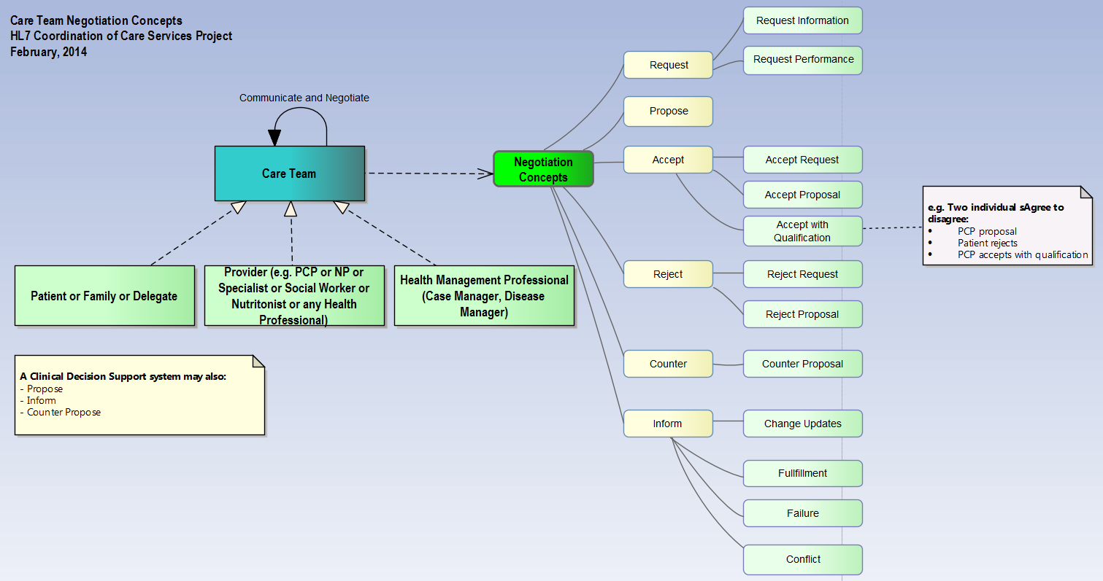

The negotiation with PCP on care plan reconciliation involves proposal, counter proposal, as described in the examples above. The process may lead to final acceptance to modify:

* Weight reduction health goal (e.g. achieve BMI reduction from 30 to 29; body weight from 97kg to 92 kg, i.e. 5kg instead of original goal of 10kg)
* Exercise program while the knee injury treatment is in place
  + The negotiations may also involve exercise physiologist, dietitian and patient
* Pain management medications to reduce the risks of cardiovascular event eventuating in the patient
  + The negotiations may also involve pharmacist

The clinical reconciliation resulted from the negotiation processes leads to a harmonized orthopaedic care plan for this patient.

The following illustration based on story board 5 depicts the complexities and importance of coordinated care. Adam Everyman is a man with multiple chronic conditions receiving care in multiple settings. His care would quickly deteriorate without a means for effective communication and the coordinated interaction of his care team.

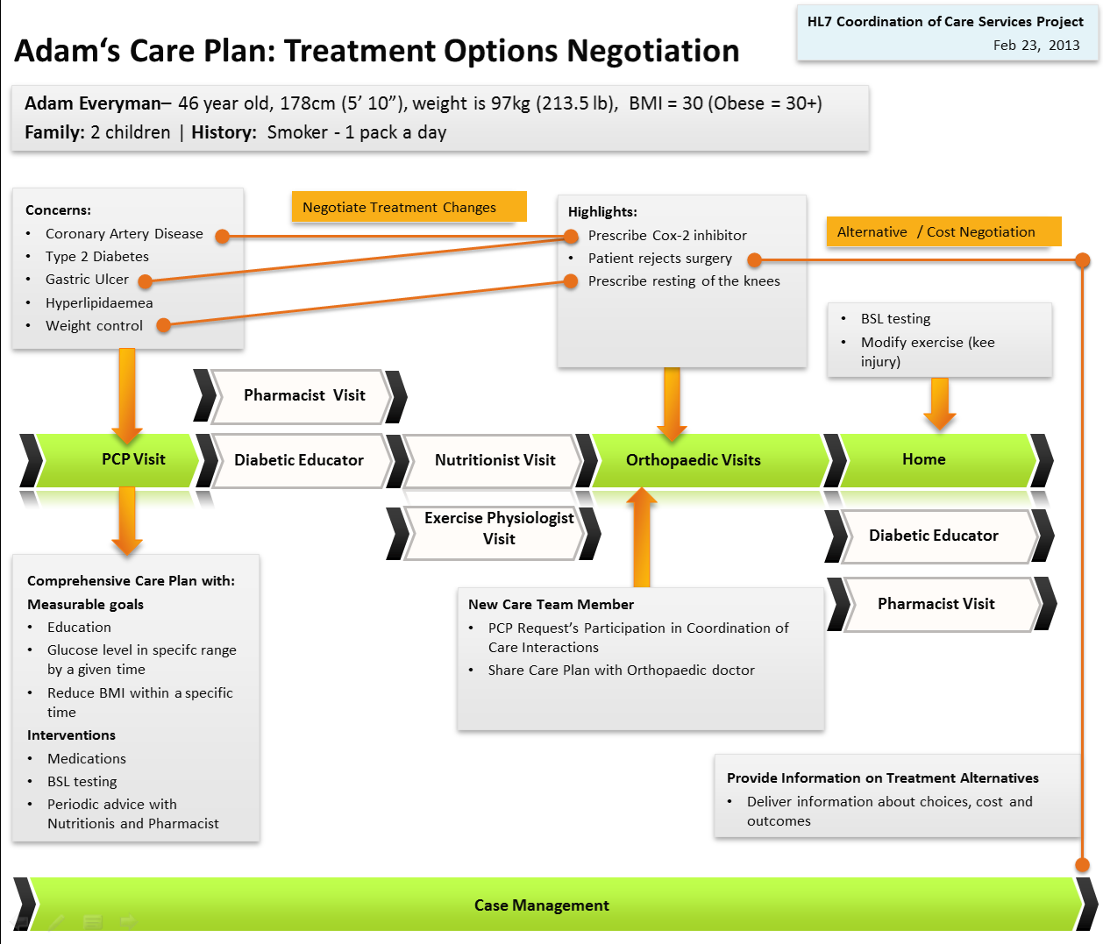

Figure 2 Adam's Treatment Options Negotiation

# Care Team Interaction Illustrations

The composition of the care team is determined by jurisdictional, organizational, credentialing body policies, and financing mechanisms. Further, it may vary based on the patient’s personal and/or family’s choice (often within the constraints of the various policies and financing mechanisms). This section assumes the existence of a care team with the goal of establishing the context of ongoing and incremental contributions to the care plan and associated care data. The patient and family are assumed to be part of the care team. A key assumption is that all members of the care team are aware of each other, have been authorized to access the care plan. It is also assumed that each member of the care team is accessing the care plan and coordinating care through a system which implements a specification derived from the service functional model described in this document.

This section describes the context and pattern of collaboration and interaction paths rather than a fixed process. Coordination of care is framed from the perspective of dynamic evolution of care driven by ongoing evaluation of the patient’s health status and collaboration of the dare team. The care team is assumed to have a shared awareness of the changing care plan which is automatically synchronized to all members as it is changed, so as to surface awareness for the need to reconcile and adjust care when new or conflicting information becomes available. Synchronization of the care plan eliminates gaps in information and breakdowns due to missing change updates, conflicting information, and incorporation of new findings. Synchronization can also expose inconsistencies and helps resolve conflict between specialty views of the plan; helping determine the need for expert clinical reconciliation. It shares information across what previously have been isolated corners of the care continuum.

The context of care team contribution starts with: Any care team member can “say” anything pertinent at any time resulting in change updates to the shared/synchronized content and resulting in notification to other care team members who in turn can react to the changes. Contribution may result in changing structured elements of the plan, health concerns, health goals, care preferences, health risks, health barriers, or the status and documentation of care activities and interventions. Care team contribution is controlled by the dynamic ongoing negotiation of care team members who may accept, reject and propose alternatives. There are other controls to care team contributions based on organization business rules and policies which are out of the scope of this specification. This specification focuses on the roles of the team members, autonomous decision making, and interaction of individuals who are acting on shared and synchronized content.

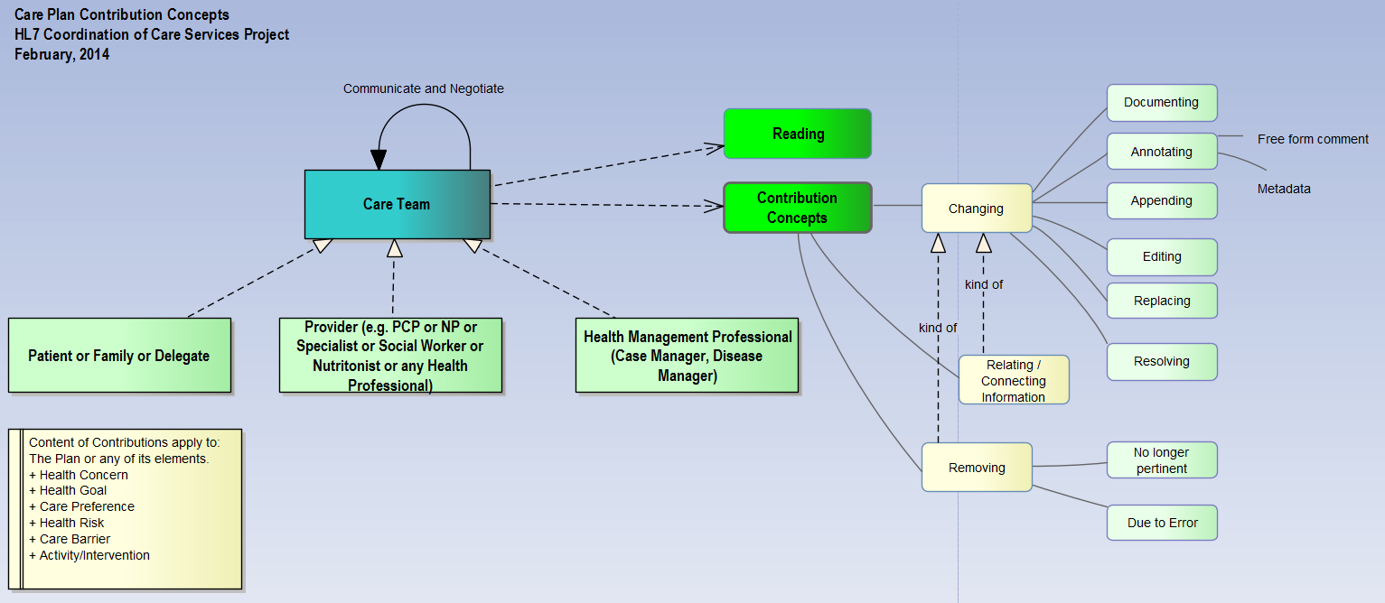

Figure 3 - Care Plan Contribution Concepts

Central to collaboration is the concept of negotiation. Care Team negotiation consists of an emergent and dynamic flow of interactions between two or more individuals as they inform each other, make requests, and make proposals. It also includes actions to accept, reject or counter the requests and proposals in order to reach agreement. It is expected that clinical decision support system agents will also participate in negotiation by proposing, informing and counter-proposing.



Figure 4 - Care Team Negotiation Concepts

The diagram in figure 5 provides an organizing framework for coordination of care dynamic models. It may be viewed as a meta-model for coordination of care interaction and collaboration models. The organizing model establishes the relationships between Health Event, Care Management Activity, Care Collaboration and Shared Content.

***Shared Content*** consists of the care plan and other associated information content. Shared content is synchronized among care team participants. The main idea is to support shared care team awareness and transparency of the patient’s care in order to eliminate gaps, redundancies and conflicts in the information and in the care process. Shared content is updated at various stages of interaction (including synchronization, harmonization, post negotiation) leading to self-organizing and reconciled systems. Shared content is incrementally created as a result of ongoing interactions.

***A Health Event*** is an occurrence of importance to the health of the patient. The event may result from a change in the patient’s physical, socio-economic status reported by the patient/family, or change in information or knowledge resulted from care management activities or from care team collaboration and interactions, which is often or should be directly recorded. The event in turn may trigger new care management activities or new collaborations and interactions which in turn result in incremental updates to the shared content and context.

***A Care Management Activity*** is the act of developing care strategies and the performance of tasks (which includes investigations, interventions and evaluations) in support of patient’s care by one or more care team members. Care management activities are indicated in the plan.

***Care Team Collaboration*** emerges during the evolution of care team evaluation, decision making and autonomous direction within the constraints of professional standards, policies, business rules, care team working agreements and social contracts.

***Business rules and policies*** are out of the scope of this specification. The meta-model simply acknowledges their existence and their relationship as a constraint in guiding care management activities and care team collaboration. Coordination of care systems would make available their model content and context to support decision making based on business rules and organization policies. The model content corresponds to the input and outputs defined in the capabilities defined in this document and the model detailed in the HL7 Care Plan DAM.

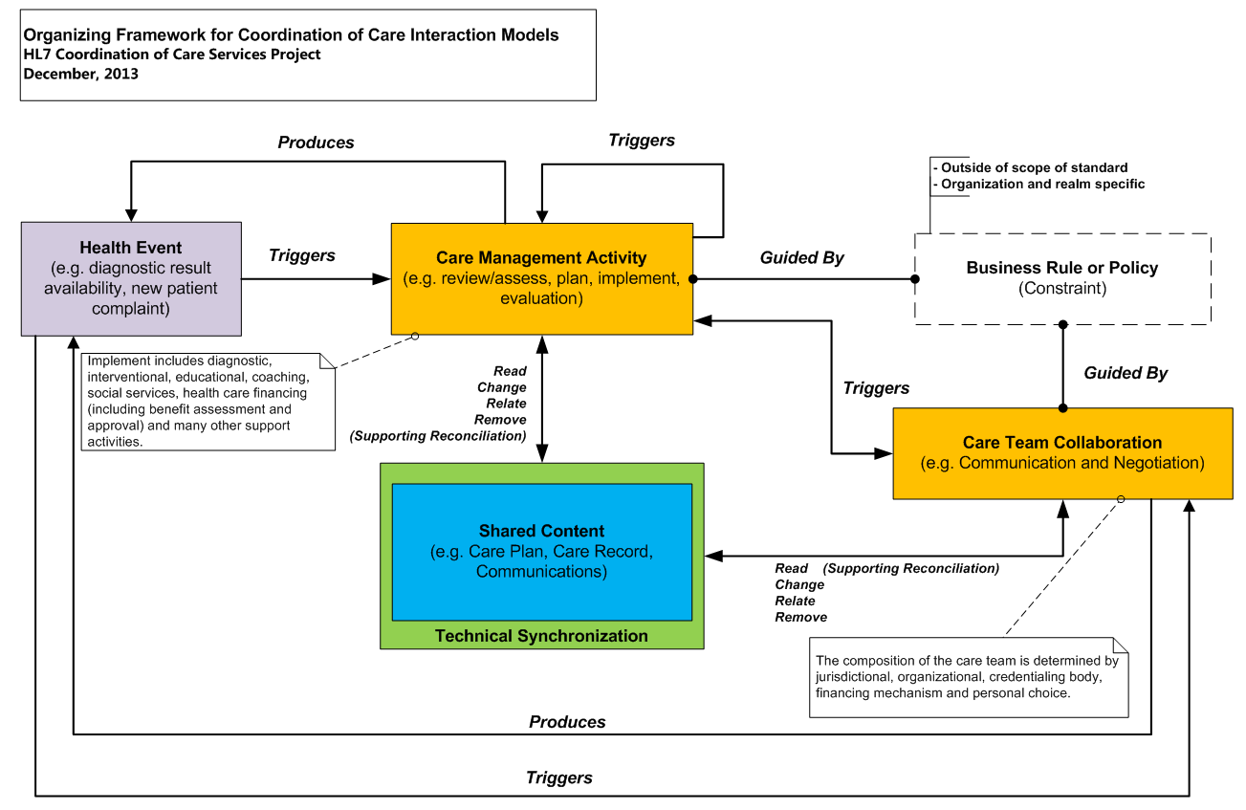

Figure 5 - Organizing Framework for Coordination of Care Interaction Models

A view of the dynamic, ongoing and emergent care team contribution based on a shared care plan may look as follows:

1. A care team member looks up an existing plan
   * A plan may be created if none exists or its existence is not known
2. The plan changes based on the care team member’s assessment with the patient
   * Health goals, care preferences, health concerns, health risks, care barriers, care activities and interventions are assessed, validated, added, changed or removed.
3. The plan leads to a cycle of intervention, outcomes and review
4. The patient may be referred to a specialist or other health and social services providers
   * The care team member requests participation from the specialist or other providers and subsequently shares the plan
5. As the patient transitions to the specialist or other health provider care settings the care event steps can be repeated with the actors represented by the generic “care team member”
6. Communication may occur at any time between care team members as they react to synchronized content change updates.

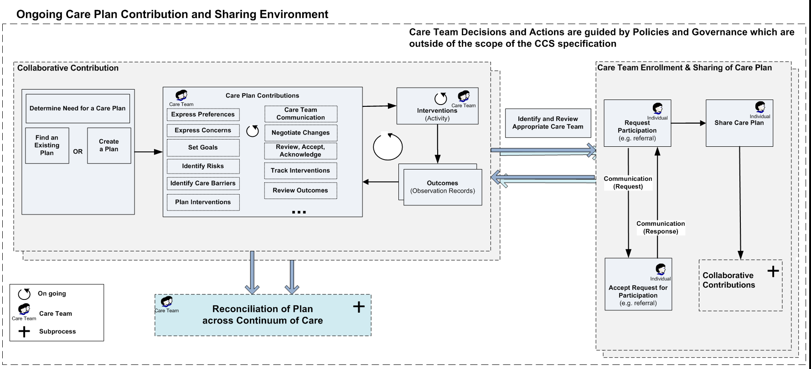

Figure 6 – Ongoing Care Team Contribution and Sharing of Care Plan

# Service Functional Model

## 5.1 Coordination of Care Service Functional Model

The “Coordination of Care” Service Functional Model (SFM) specifies discrete functions or capabilities required for the development of electronic systems which support coordination of care by a collaborating care team. The functional capabilities represent discrete steps in dynamic coordination of care interactions. They may be used in different combinations to help orchestrate the care coordination in collaborative care environments. An important aspect of coordination of care interactions is that they are non-deterministic in nature; interaction emerges and evolves based on expert or autonomous decision making of the care team.

The capabilities are described in terms of business level pre-conditions, inputs, outputs, exception conditions and post-conditions. The inputs and outputs will have representations mainly as patient care information model classes but sometimes the specification will indicate service centric concepts such as acknowledgements of requests. The pre-conditions, post-conditions and exceptions will only be indicated when significant to the domain (e.g. technical level exceptions, pre-conditions and post-conditions will not be elaborated).

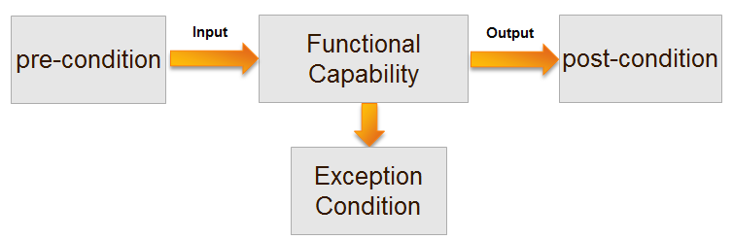

Figure 7 - Structure of a Capability

|  |  |
| --- | --- |
| C:\Users\Enrique Meneses\AppData\Local\Microsoft\Windows\Temporary Internet Files\Content.IE5\ERJN7ZZZ\MC900441312[1].png | A functional capability as described in this document does not represent a software function implementation. The future technical specification which will be derived from this SFM will provide a technology platform binding which supports interoperable software implementations. |

#### 5.1.1 Governance, Policies and Business Rules

The functional capabilities do not dictate a model for governance, policy or application of specific business rules as these may vary by country and organization. Governance, policies and business rules are a level of constraint which is expected to be applied at the implementation level of a technical specification.

#### 5.1.2 Perspective

The perspective taken in the specification of the functional capabilities is grounded in the following concepts:

* Coordination of care is a collaborative activity of care teams (which includes the Patient)
* Coordination of care spans organizational boundaries and settings (including the home)
* Explicit awareness of the identity of the *care team* is a requirement for:
  + Determining which individuals require information to prevent misunderstanding and communication gaps.
  + Supporting follow up, feedback, communication.
  + Supporting shared understanding of the patient’s care plan and communication of changes andupdates regarding health goals, care preferences, health concerns, health risks, care barriers, and supporting activities and interventions.
* Care teams acting on a shared and synchronized care plan facilitate non-conflicting and harmonized health goals, care preferences, health concerns, health risks, care barriers and supporting activities and interventions.
* The care plan and related clinical content changes based on dynamic contributions over time by a multidisciplinary care team. Information is out of date the moment it is exchanged and therefore supporting care team awareness of changes in a timely manner is crucial in improving care planning and delivery.
* A shared and synchronized *care plan* evolves based on on-going care team interactions
  + Information for new health goals, care preferences, health concerns, health risks, care barriers and supporting activities and interventions is pushed to the care team as a result of new interactions (on a need to know basis which respects organizational rule and policies)
  + Harmonization or reconciliation occurs during interactions since the *care team* has a shared awareness of the *care plan* and ongoing negotiation facilitates resolution of conflicts (at the point of interaction)

#### 5.1.3 Assumptions

This section assumes familiarity with the *HL7 Care Plan* domain analysis model (May 2014 ballot). A glossary of terms is also included in this document.

#### 5.1.4 General Grouping of Capabilities

The capabilities are grouped into related groups as follows:

* Care Team Membership Capabilities
* Care Team Communication Capabilities
* Care Team Availability/Scheduling Capabilities
* Care Plan Management Capabilities
* Plan Templates
* Plan Resource Support Capabilities
* Progress and Outcome Review Capabilities
* Observations and Supportive Content Capabilities

## 5.2 Care Team Membership Capabilities

Coordination of Care is an activity of collaborating care teams. Explicitly maintained knowledge of the currently active care team members, their responsibilities, commitments and contribution to the care of the patient are essential for deciding how to harmonize potentially conflicting decisions and actions, and incorporating new information into a comprehensive and dynamic care plan.

The first set of capabilities described support defining who the care team is and how the individual members relate to each other. Membership in a patient’s care team is a pre-requisite for communication, negotiation and acceptance of individual contributions to a comprehensive patient care plan. The functional capabilities described in this document restrict coordination of care to individuals who have been accepted as members of the care team; care team membership within the coordination of care system (CCS) is a perquisite for interaction based on the capabilities described in this document.

#### 5.2.1 Request Participation

###### 5.2.1.1 Description:

This capability supports making a request from one individual to another to participate as a collaborator in coordination of care activities for one patient. This request for participation establishes privileged membership into the circle of care for a single patient. Membership is a pre-condition for subsequent interactions resulting from referrals, transitions of care, consultations, etc.

The “request for participation” function assumes the existence of a pre-existing working or social relationship between the participants or organizations involved which enables them to collaborate and coordinate care based on current practice (whether through faxes, phone calls or other means). The issue of which professionals and non-professionals are on the patient’s actual care team (and who can receive requests) is an independent issue, is out of scope for this specification and constrained by country or organization governance and policies.

###### 5.2.1.2 Examples:

* A patient may request participation from a family member or care giver with a stake in the coordination of the patient’s care.
* A patient’s family member or care giver who has accepted membership to the care team may request participation of another individual such as a provider, care giver, administrative service member, etc.
* A primary care provider may request participation from an oncologist after a patient’s diagnosis with cancer.

###### 5.2.1.3 Specification:

|  |  |
| --- | --- |
| **Preconditions** | * Institutional or jurisdictional policy will dictate who can make a request for participation * Consent from the patient, authorised patient representative (e.g. person who has enduring power of attorney) |
| **Inputs** | * Request placer **:** Person Class * Request placer role **:** Role Class * Subject of Care **:** PersonAsPatient Class * Request recipient **:** Person Class * Request recipient role**:** Role Class * Request text or information from request placer **:** Communication Class |
| **Outputs** | * Acknowledgement of receipt of request |
| **Postconditions** | Recipient receives a communication with the details of the request to join the specific patient’s care team |
| **Exception Conditions** |  |
| **Notes** | * An invitation could be cancelled by the sender * An invitation could have an expiration time if not accepted within a given timeframe by the recipient |

#### 5.2.2 Respond to Participation Request

###### 5.2.2.1 Description:

The “Respond to Participation Request” capability supports the ability of individuals to accept, reject or delegate an invitation to join a patient’s care team.

An invitation response results in the addition of a new care team participant upon acceptance. The recipient of the invitation may also reject the invitation or delegate to a colleague.

Allowed response types are:

* Accept participation request
* Decline request with recommendation
* Reject request to participate

###### 5.2.2.2 Examples:

* An oncologist accepts a primary care provider’s request to join the patient’s care team.
* A cardiologist delegates request for participation to a colleague due to unavailability or capacity to take new patients.
* An orthopaedic surgeon rejects request to join the care team because a rheumatologist is better suited to manage the patient’s health concern/problem.

###### 5.2.2.3 Specification

|  |  |
| --- | --- |
| **Preconditions** | Existence of a pending request for participation |
| **Inputs** | * Participation request placer **:** Person Class * Subject of Care **:** PersonAsPatient Class Response Type **:** Participation Response Type Class |
| **Outputs** | * Acknowledge receipt by recepient |
| **Postconditions** | New individual joins the patient’s care team and starts receiving change updates. |
| **Exception Conditions** |  |

#### 5.2.3 Add Care Team Member

###### 5.2.3.1 Description:

The “Add Care Team Member” capability supports the ability of an authorized user to directly add members to the care team. The capability assumes the existence of an administrative role which has been granted access to plan and assign members of the care team. This capability can help streamline establishment of the care team when the patient is receiving care within a single institution and an initial group of individuals is identified during care planning.

###### 5.2.3.2 Examples:

A patient scheduled for a surgery with an expected inpatient stay lasting more than a week would have an inpatient care team where some individuals are known ahead of time and can be added by an administrative hospital provider.

###### 5.2.3.3 Specification

|  |  |
| --- | --- |
| **Preconditions** | Performer must be an authorized user with rights to assign membership the patient’s care team. |
| **Inputs** | * Function performer **:** Person Class * Function performer role **:** Role Class * Subject of Care **:** PersonAsPatient Class New care team member**:** Person Class * New care team member role**:** Role Class * Request text or information with reason for addition to be sent to new care team member **:** Communication Class |
| **Outputs** | * Acknowledgement of addition of new care team member |
| **Postconditions** | * New and existing care team members receive communication informing them of new membership and reason as indicated by administrative user. * New individual joins the patient’s care team and starts receiving change updates. |
| **Exception Conditions** |  |
| **Notes** | Intra-organization use cases should make use of the “Request Participation” capability. |

#### 5.2.4 List my Care Teams

###### 5.2.4.1 Description:

The “List my Care Teams” capability supports the ability of an individual to list all care teams for which they have an active membership.

###### 5.2.4.2 Examples:

* A man has personal membership to his own care team and to the care teams for his mother and father.
* A provider has a personal membership to her own care team and professional membership the care team for all her patients.

###### 4.2.4.3 Specification

|  |  |
| --- | --- |
| **Preconditions** | Some care team membership |
| **Inputs** | * Function performer **:** Person Class * Function performer role **:** Role Class * Membership type **:** Membership Type   + e.g. Personal membership or Professional membership |
| **Outputs** | * Zero or more persons and their roles : Person with Role Class |

#### 5.2.5 Remove Care Team Member

###### 5.2.5.1 Description:

The “Remove Care Team Member” capability supports the ability of an authorized user to either permanently remove or inactivate an individual from the care team. The capability supports administrative management of the care team. The capability also supports a patient or patient delegate to decide the composition of their active care team and who has access to their plan and progress. Care team members who are permanently removed no longer have access to the care plan. Care team members who are inactivated continue to have access but no longer receive full communication of updates (unless there is an explicit request to re-engage them).

###### 5.2.5.2 Examples:

* A system administrator removes a retired physician or nurse from the patient’s care team.
* A patient changes providers and removes their old providers from their care team.
* Temporary members added during an inpatient stay are removed from the care team.
* An individual responsible for the care of an elderly parent removes health care specialists no longer involved with the care of the patient.
* A cardiologist sees an individual for evaluation of a murmur.  After a consult and diagnostic tests, the cardiologist says, "The murmur is not significant at this time, but if symptoms develop over time or your PCP advises you should return to see me." The cardiologist is kept as an inactive member of the care team.

###### 5.2.5.3 Specification

|  |  |
| --- | --- |
| **Preconditions** | Performer must be a privileged user with rights to remove individuals from the patient’s care team. |
| **Inputs** | * Function performer **:** Person Class * Function performer role **:** Role Class * Subject of Care **:** PersonAsPatient Class Care team member to remove **:** Person Class * Removal type : Code Type (e.g. Permanent or Inactive) * Reason for removal **:** Removal Reason Type Cass |
| **Outputs** | * Acknowledgement of care team member removal * Communication of removal is sent indicating details of removal including date, performing person, patient and reason. |
| **Postconditions** | * Individual stops being part of the care team. Individual loses access to patient’s care plan and associated coordination of care communications. |
| **Exception Conditions** |  |

#### 5.2.6 Discover Care Team

###### 5.2.6.1 Description:

The “Discover Care Team” capability supports the ability of a user to determine who the other members of the care team are in order to engage them in communication, negotiation, harmonization and coordinated execution of the plan (via the other capabilities defined in this specification).

This capability also supports computer systems in determining who needs to receive change updates and synchronization of the care plan and other coordination of care context and information.

The capability is designed to allow care team individuals to know about each other. In a sense, this capability provides a graph or personal relationships.

###### 5.2.6.2 Examples:

A PCP makes a referral to a cardiologist by sending a “request for participation” in the care team.

The cardiologist subsequently after the first patient encounter sends a “request for participation” to a dietician and physical therapist (who are not known to the PCP).

Upon the next review of the care plan the PCP becomes aware of the new care team members and how their actions and contributions affect the patients plan and progression of their care. The awareness is supported by automatic discovery of new care team members by the system.

###### 5.2.6.3 Specification

|  |  |
| --- | --- |
| **Preconditions** | * Determination of the care team is designed for awareness within the patient’s extended care circle. It includes only those members who have explicitly sent “requests for participation” to each other; or who have been explicitly added by an administrator via the “add care team member” capability. |
| **Inputs** | * User **:** Person Class * User **:** Role Class * Subject of Care **:** PersonAsPatient Class |
| **Outputs** | * Care team network **:** Care Team Class   + Graph of persons, their relationships and connection history (a network) |
| **Postconditions** | None |
| **Exception Conditions** |  |

## 5.3 Care Team Communication Capabilities

Effective care team communication is a key requirement of coordination of care and collaboration. These capabilities support electronic communication between individuals and maintenance of a record of significant coordination of care communications or messages between individuals for future review, understanding and awareness.

It is important to note that for communications to be meaningful for coordination of care they must be associated with the specific clinical context which triggered the communication. The HL7 Care Plan domain analysis model defines communications with explicit associations to health goals, health concerns, health risks, care barriers and plan activities or interventions. For example, a question (communication) about a health goal would be linked to the health goal structure defined in the model; sharing of information about an intervention would have a link to the plan activity as defined in the model.

#### 5.3.1 Send Message to Care Team Member(s)

###### 5.3.1.1 Description:

The “Send Message to Care Team Member(s)” capability supports the ability of a user to send a message to one or more care team members. By default the conversation is private to the participants involved. Organizational policies and business rules may determine if a conversation is visible beyond the direct participants involved.

This capability supports both sending of new messages as well as responding to previously sent messages.

Some characteristics of messages:

* Messages capture the free form text, natural language expression of business interactions.
* Messages may capture structured observations resulting from electronic form question/answers.
* Messages link to the semantic structure or context pertaining driving the interaction. These links put the communication in context.
* Messages are organized in threads with a common topic.
* Messages may contain optional multimedia such as an attached photograph, video clip or document.

###### 5.3.1.2 Examples:

* A PCP requests an update from a mental health specialist regarding a special area of concern.
* A patient sends a question to one of her providers
* A patient sends weekly communication to provide a status update in response to a request from her physician to note how they feel about their treatment (capturing the information via a form with structured observations).
* A care team member broadcast an informational message to the entire care team to inform them of a potentially serious side effect requiring changes to treatment and adjustments to the plan.
* A message is sent to the care team during an informal consult with a radiologist to ask if a particular imaging procedure might be indicated for the patient given certain circumstances. The radiologist is not part of the system maintained care team but has the capability to inform or share information with any of them via the “send message” capability.

###### 5.3.1.3 Specification

|  |  |
| --- | --- |
| **Preconditions** | * Messages can only be addressed to care team members for one patient |
| **Inputs** | * Message **:** Communication Class   + The communication class specifies sender, recipient and links to context and observations. |
| **Outputs** | Acknowledgement of receipt by receiving systems |
| **Postconditions** | One or more care team members receive new message / communication |
| **Exception Conditions** | Transmission errors resulting in failure to send to receiving system |

#### 5.3.2 Include Additional Care Team Member(s) in Communication

###### 5.3.2.1 Description:

The “Include Additional Care Team Member(s) in Communication” capability supports the ability of a user to include additional care team members in an existing communication.

###### 5.3.2.2 Examples:

The initial communication after a transition of care is sent to the primary receiving provider. Upon receipt and reading the message the provider decides to include the rest of the care team (after either adding them directly or sending them a request to join the care team).

###### 5.3.2.3 Specification

|  |  |
| --- | --- |
| **Preconditions** | * Only individuals who are part of the care team can be added to the communication. * This may require sending the request to participate/join the care team or adding them directly if performed by a privileged user. |
| **Inputs** | * Message **:** Communication Class   + The communication class specifies sender, recipient and links to context and observations.   + A technical specification based on this capability may choose to use a unique identifier in place of the communication.   Multiple entries for:   * New person to include: Person class * Role of new person : Role Class |
| **Outputs** | Acknowledgement of receipt by receiving systems |
| **Postconditions** | One or more care team members receive new message / communication indicating that they have been included in a prior / past conversation (to distinguish from a recent interaction). |
| **Exception Conditions** | Transmission errors resulting in failure to send to receiving system |

#### 5.3.3 List Messages

###### 5.3.3.1 Description:

The “List Messages” capability supports the ability of users to obtain a listing of messages they have either sent or received as part of their active membership in a given patient’s care team. Listing of messages may also include filters based on tags which have been applied to the message by users or tags applied to the message by systems.

###### 5.3.3.2 Examples:

* List messages received
* List new (unread) messages received
* List messages sent by user
* List messages tagged as removed
* As a PCP list messages tagged for a specific condition

###### 5.3.3.3 Specification

|  |  |
| --- | --- |
| **Preconditions** | Existing member of the care team with a history of sent and received messages |
| **Inputs** | * User **:** Person Class * User role **:** Role Class * Subject of Care **:** PersonAsPatient Class (identifies which care team membership to use) * One or more tags to use as filters **:** ObjectTag Class   + E.g. Sent_Messages, Received_Messages, New_Messages   + Or user defined tags such as Cardiology, Diet, Exercise * Start date : Date Class [optional] * End date : Date Class [optional] |
| **Outputs** | One or more communications or communication threads **:** Communication or Communication Thread Class |
| **Postconditions** | None |
| **Exception Conditions** |  |

#### 5.3.4 Tag Messages

###### 5.3.4.1 Description:

The “Tag Messages” capability supports the ability of users or systems to tag messages for categorization and organization purposes. Tags are used as filters when listing messages.

Three specific tags reserved by systems include: Sent_Messages, Received_Messages and New_Messages.

###### 5.3.4.2 Examples:

* A system marks messages as either sent or received in order to support a coherent listing of messages.
* A patient may tag specific messages to organize information based on whatever internal model suites them.
* A primary care provider may organize messages based on specific conditions in order to streamline their use when listing and filtering messages.

###### 5.3.2.3 Specification

|  |  |
| --- | --- |
| **Preconditions** | Existing member of the care team with a history of sent and received messages |
| **Inputs** | * User **:** Person Class * User role **:** Role Class * Message **:** Communication Class * One or more to associate with message**:** ObjectTag Class   + E.g. Sent_Messages, Received_Messages, New_Messages   + Or user defined tags such as Cardiology, Diet, Exercise |
| **Outputs** | Acknowledgement of successful application of tags to message |
| **Postconditions** | Message has additional associated metadata tags available for inclusion when listing messages |
| **Exception Conditions** |  |
| **Notes** | It is expected that the technical specification will include a complementary operation to also remove user defined messages tags. System assigned tags cannot be removed. |

#### 5.3.5 Care Team Negotiation

###### 5.3.5.1 Description:

Negotiation is an interaction between two or more parties with the aim to reach agreement. Negotiation is supported in two ways by the coordination of care service functional model.

1. As free form “electronic message” communication resulting in care team individuals taking specific actions
   1. This form is not too different from a phone- or email- based negotiation in that the exchange happens as a conversation with a very specific agreed on decision
2. As a structured content contribution to the care plan, which occurs when a care team member adds a health goal, a health concern or a care activity or intervention. Depending on the role and situation, the added goal, concern or intervention may be in a non-finalized proposed state. The proposal could be accepted, rejected or an alternative could be counter-proposed. The flow in this style of negotiation is one where the care team contributes to the same plan shared content; but the plan or its elements are not accepted (via a team acceptance review) until agreement has been reached.

The modes of communication during the negotiation processes can be asynchronous or synchronous

This capability supports the ability of users to annotate the care plan and its elements as: requested, proposed, accepted, rejected or counter proposed.

###### 5.3.5.2 Examples:

* A patient disagrees that he/she has weight problem (health concern) and rejects that they have to reduce their weight to stay healthy (health goal and intervention).
* An orthopaedic surgeon negotiates treatment changes with a PCP as the Cox-2 inhibitor she is prescribing would require changes to the medications prescribed for the patient’s coronary artery disease. The orthopaedic surgeon does this by attaching a proposal and annotation to the previously agreed to interventions for coronary artery disease.

###### 5.3.5.3 Specification

|  |  |
| --- | --- |
| **Preconditions** | * Un-finalized care plan aspects requiring proposals of changes or new issues/new clinical information becomes available necessitate change(s) to care plan * Disagreement on a course of action * Detection of conditions which may lead to an un-harmonized plan andsuboptimal outcomes |
| **Inputs** | * Initiating user **:** Person Class * Initiating user role **:** Role Class * Focus of negotiation **:** Plan, Health Goal, Health Concern or Care Activity Class (aka Intervention) * Free form expression : Communication Class |
| **Outputs** | * Plan, Health Goal, Health Concern or Care Activity Classes are annotated with ObjectTags capturing the negotiation mode of propose, accept, reject, counter propose |
| **Postconditions** | * Participating care team members receive communication of negotiation response |

**NOTE** – the list of preconditions included the above are examples only. The list is not intended to be exhaustive.

## 5.4 Care Team Availability/Scheduling Capabilities

#### 5.4.1 Indicate Availability

###### 5.4.1.1 Description:

The “Indicate Availability” capability supports the ability of users to publish open times in their schedule as well as times when they are not available.

###### 5.4.1.2 Examples:

* A specialist may publish times he is available to indicate to the collaborating team that he can meet, receive new patients or take additional care responsibilities at the specified times.
* A PCP may indicate that she is off for two weeks of vacation.

###### 5.4.1.3 Specification

|  |  |
| --- | --- |
| **Inputs** | * Time slots : Schedule Time Slot Class   + The time slot indicates a time point or time period for which the individuals is either available or un-available |
| **Outputs** | Acknowledgement availability has been captured by the system |

#### 5.4.2 Find Person Availability

###### 5.4.2.1 Description:

The “Find Person Availability” capability supports the ability of users to discover when their peers are available for meetings or new appointments with patients.

###### 5.4.2.2 Examples:

* A cardiologist finds a time to discuss critical plan changes with the patient’s primary care provider.
* During a primary care visit the patient makes an appointment request with a social worker.

###### 5.4.2.3 Specification

|  |  |
| --- | --- |
| **Preconditions** | There is a shared care team between the individuals |
| **Inputs** | * Care team members to determine availability **:** Person Class * Time slot prototypes to match **:** Schedule Time Slots |
| **Outputs** | Available schedule time slots for care team member |

#### 5.4.3 Reserve Person Availability

###### 5.4.3.1 Description:

The “Reserve Person Availability” capability supports the ability of users to reserve a slot in another care team member’s schedule based on information determined from the “Find Person Availability” capability.

###### 5.4.3.2 Examples:

* A cardiologist reserves a time on the patient’s PCP schedule to discuss critical plan changes based on the patient’s primary care provider’s availability discovered by the find availability capability.
* During a primary care visit the patient makes an appointment request with a social worker.

###### 5.4.3.3 Specification

|  |  |
| --- | --- |
| **Preconditions** | There is a shared care team between the individuals |
| **Inputs** | * Request communication : Communication Class   + May indicate a link to a subject of Care **:** PersonAsPatient Class   + Indicates request reason text   + May indicate a link to any pertinent care plan elements : Any of multiple classes from Care Plan DAM * Requested schedule time slot for care team member : Schedule Time Slot Class |
| **Outputs** | Acknowledgement of receipt of communication by receiving system |
| **Postconditions** | A response either immediately or sometime later confirming reservation of time slot |

## 5.5 Care Plan Management Capabilities

The care plan provides guidance for the coordinated effort of the care team. Are care team individuals acting in accordance with the goals established by the patient and her providers? Is everything which was previously planned still the correct course of action upon the identification of new health concerns, risks or barriers? Does the outcome of plan activities by one provider impact the planned course of action agreed upon with a different provider? As time goes on the plan continues to evolve based on contributions from different care team stakeholders and may require harmonization via communication and negotiation. The plan provides a direction to the coordinated activities of the care team; breakdown occurs when the plan stops being maintained. In other words, lack of a dynamically maintained plan results in breakdown of coordinated care.

#### 5.5.1 Create Plan

###### 5.5.1.2 Description:

The “Create Plan” capability supports the ability of a care team member (which includes the patient) to establish a new plan for the patient; or for a patient to create a plan for herself without the need or involvement of other care team members. The capability may not always result in the creation of a complete plan but may simply create the shell of a plan to which one or more care team members in coordinated effort with the patient will contribute information about health goals, heath concerns, health risks, care barriers and plan activities or interventions. The completeness is a matter of perspective and is something that is continuously evolving with future findings so it is expected that whether the created plan is “complete” or a shell it will still undergo changes through contributions by others.

###### 5.5.1.3 Examples:

* A comprehensive plan is created for a patient with multiple chronic conditions by her primary care provider. The plan does not specify much other than identification of health concerns for coronary artery disease, obesity and diabetes mellitus. This shell of a plan is expected to be elaborated with more detail, with achievable goals and interventions during future visits with other specialists. The specific circumstances determine how and when the plan becomes activated for management of a specific condition.
* A healthy patient may create a plan to achieve better health (may be driven by health concerns or only a health goal)

###### 5.5.1.4 Specification

|  |  |
| --- | --- |
| **Preconditions** | User must be the patient or some other member of the patient’s care team |
| **Inputs** | * Plan **:** Plan Class   Require either health concerns or health goals:   * Zero or more health goals  **:** Health Goal Class * Zero or more health concerns  **:** Health Concern Class * Zero or more health risks **:** Health Risk Class * Zero or more care barriers **:** Care Barrier Class * Zero or more planned interventions **:** Care Activity Class * At least one health goal or one health concern is required. |
| **Outputs** | * Acknowledgement of creation of plan * Notification to care team about existence of new plan |
| **Postconditions** | * Plan is created and synchronized with patient’s care team |
| **Exception Conditions** | * Unauthorized if individual not a member of the care team * Duplicate or existing plan already in place which could lead to diverging and un-reconciled care. |

#### 5.5.2 Change Plan

###### 5.5.2.1 Description:

The “Change Plan” capability supports the ability of care team members (which includes the patient) to make changes to an existing plan. The changes may include modification to intrinsic plan attributes such as confidentiality, description, display name and discipline or changes (including addition) of related plan elements such as health concerns, health goals, health risks, care barriers and plan activity or interventions. A change could represent the removal of plan elements either because they are no longer pertinent or because they were added due to some error. Changes to the plan may also include status changes such as placing the plan on hold or suspending the plan for a period of time.

###### 5.5.2.2 Examples:

* Plan intrinsic attributes for discipline and description are modified upon identification of new health concerns for coronary artery disease and diabetes mellitus.
* A healed fracture of the leg is removed as a health concern from the plan.
* New interventions are added to the plan to support blood glucose monitoring by the patient at their home.
* A health goal which the patient never agreed to is removed from the plan.
* The priority and success criteria of a health goal are changed by a PCP during conversations with the patient.

###### 5.5.2.3 Specification

|  |  |
| --- | --- |
| **Preconditions** | User must be the patient or some other member of the patient’s care team |
| **Inputs** | * Plan **:** Plan Class capturing the changed intrinsic attributes   Addition or removal of any of the following:   * One or more health goals  **:** Health Goal Class * One or more health concerns  **:** Health Concern Class * Zero or more health risks **:** Health Risk Class * Zero or more care barriers **:** Care Barrier Class * Zero or more planned interventions **:** Care Activity Class * Changes to intrinsic properties of health concerns, health goals, health risks, care barriers and care activity |
| **Outputs** | * Acknowledgement of successful modification of plan * Notification to care team about changes to the plan * Synchronization of the plan change updates to shared copies of the plan |
| **Postconditions** | Plan is updated and care team is aware of change updates |
| **Exception Conditions** |  |
| **Notes** | This capability will expand into multiple technical specification operations to support making changes to different component parts of the plan. |

#### 5.5.3 Monitor Change

###### 5.5.3.1 Description:

The “Monitor Change” capability supports the ability of users to indicate their desire to be alerted regarding specific changes to the care plan content such as health concerns, health goals, health risks, care barriers, care preferences and care activities or interventions. As specified by the “Plan Synchronization” capability, the care plan content is already expected to be synchronized across all shared instances. The key distinction of the “Monitor Change” capability and basic synchronization is that synchronization is a passive behavior of the system; whereas “Monitor Change” supports intentional and proactive care team behavior.

###### 5.5.3.2 Examples:

* A coordination of care system is set up so that some providers can monitor addition of new health concerns so that they can reevaluate the plan and potentially harmonize changes from other care team providers.
* A case manager may monitor unmet goals for a patient in order to follow up with care team stakeholders.

###### 5.5.3.3 Specification

|  |  |
| --- | --- |
| **Preconditions** | Existing plan is in place and the care team which includes the patient has agreed to it. |
| **Inputs** | * One or more care team members (including patient) interested in monitoring **:** Person Class * Tagged plan elements or health events with indication for monitoring * Monitor criteria **:** Criterion Class   + These are rules that define what to monitor |
| **Outputs** | A communication is sent to the user with links to the relevant plan elements **:** Communication Class |
| **Postconditions** | Users receive communication with links to plan element and criteria used as the trigger |

#### 5.5.4 Find Plan

###### 5.5.4.1 Description:

The “Find Plan” capability supports the ability of care team members to discover existing plans for a patient in order to make the plan accessible for reading, reviewing and changing. The resulting plans may be either active or archived. Ideally there is one active plan for a patient as the capabilities do not support coordination of care based on multiple un-reconciled plans.

###### 5.5.4.2 Examples:

A patient presents to an appointment with their cardiologist. The cardiologist who was previously requested to participate in the care team via a PCP referral looks up the existing plan to review with the patient.

###### 5.5.4.3 Specification

|  |  |
| --- | --- |
| **Preconditions** | Individual must either be a patient or another member of the care team in order to look up a plan. |
| **Inputs** | * User **:** Person Class * User role **:** Role Class * Subject of Care **:** PersonAsPatient Class |
| **Outputs** | * Plan **:** Plan Class   + The plan class has associations to health concerns, health goals, health risks, car barriers, patient preferences, care activities, etc.   + These associated elements are available to the individuals requiring access to the plan. |
| **Postconditions** | * Plan becomes accessible to care team member |
| **Exception Conditions** | * Unauthorized if individual not a member of the care team |

#### 5.5.5 Plan Synchronization

###### 5.5.5.1 Description:

The “Plan Synchronization” capability supports system level data synchronization of changes to the care plan for all care team participants who have accessed an earlier version of the plan and who may make mistakes unless they are aware of changes to the plan. The capability supports users by providing an up to date view and awareness of changes to the plan by other care team members. Synchronization of change updates to the coordinating care team raises awareness of potential changes resulting from new findings.

###### 5.5.5.2 Examples:

A patient is discharged from a hospital and transferred to a skilled nursing facility. There are pending diagnostics tests at the time of discharge. A day later upon review of the test results the responsible provider determines the abnormal lab results indicate the patient medications must be changed immediately. The provider proposes changes to the plan which are synchronized to other coordinating care team member version of the plan; making the changes available to the attending provider at the skilled nursing facility so they can avoid unnecessary complications.

###### 5.5.5.3 Specification

|  |  |
| --- | --- |
| **Preconditions** | Multiple care team members with access to the plan which becomes out of date when modified by another care team member possibly in a different setting and organization. |
| **Inputs** | Change updates: Requires a system level synchronization protocol to be determined at the technical specification level. |
| **Outputs** | Production of change update summary with special emphasis in tracking changes with temporal significance. |
| **Postconditions** | Out of date versions of the plan held by coordinating care team members are updated |
| **Exception Conditions** | System level unavailability exceptions which may require re-attempting the synchronization process. |

#### 5.5.6 Close the Plan

###### 5.5.6.1 Description:

The “Close Plan” capability supports the ability of users to indicate a plan is no longer used.

###### 5.5.6.2 Examples:

* Patient heals and provider decides to create a brand new plan and closes existing plan (instead of changing the existing plan which is also an option).
* Duplicate plan is closed.
* Patient dies and plan is closed.

###### 5.5.6.3 Specification

|  |  |
| --- | --- |
| **Preconditions** | An active or current plan |
| **Inputs** | User **:** Person Class  User role **:** Role Class  Subject of Care **:** PersonAsPatient Class |
| **Outputs** | The status of the plan is set to “closed” |
| **Postconditions** | * The plan is no longer available for use and modification by the care team. * The plan will be available as a result in the find plan capability when if the query indicates retrieval of historical plans. |
| **Exception Conditions** |  |

#### 5.5.7 Tag Plan Items

###### 5.5.7.1 Description:

In the world of paper care plans, one could take a red pen and make “markings” to identity items of interest for planning and discussion. As an example, these markings may indicate to follow up, to correct, to consolidate or reconcile various plan sections or items.

The “Tag Plan Items” capability supports the ability of users to make such markings by tagging any object within the plan with a label (which could be a predefined or coded label). The markings could be either system defined or user defined.

Markings with the same label or code form groupings of related content for organizational purposes or to highlight them for future action by the care team.

###### 5.5.7.2 Examples:

* Care team members may tag conflicting goals that need to be discussed
* Care team members may tag two plans to merge
* Care team members may tag plan items requiring review or follow-up.

**Example Tags:** Follow up item, Conflicting item, Duplicate item, No Longer Relevant Item, Item Review required

###### 5.5.7.3 Specification

|  |  |
| --- | --- |
| **Preconditions** | User is a member of the care team |
| **Inputs** | * User **:** Person Class * User role **:** Role Class * Tag **:** ObjectTag Class   + Captures label or code   + Timepoint or time period for which the tag is relevant   + A reference to one or more target objects from the plan to which the tag is applied |
| **Outputs** | Acknowledgement confirming tagging was successful |
| **Postconditions** | Application of tags is synchronized to plans held by other care team members |
| **Exception Conditions** |  |
| **Notes** | The reverse capability to untag or to remove a tag should also be supported by the specification. |

#### 5.5.8 Lookup Tagged Items

###### 5.5.8.1 Description:

The “Lookup Tagged Items” capability supports users in identifying plan items tagged with a given label. Tag with the same label or code form groupings of related content for organizational purposes or to highlight them for future action by the care team.

###### 5.5.8.2 Examples:

* List items tagged for reconciliation
* List post discharge items tagged for follow up
* List conflicting items tagged by clinical decision support agent

###### 5.5.8.3 Specification

|  |  |
| --- | --- |
| **Preconditions** | User is a member of the are team |
| **Inputs** | User **:** Person Class  User Role **:** Role Class  Subject of Care **:** PersonAsPatient Class Tag **:** ObjectTag Class to be used as prototype for query   * May indicate applicability time period (as tag may no longer be “active”) |
| **Outputs** | Information used by computer system to locate and present tagged plan objects to user |
| **Postconditions** |  |
| **Exception Conditions** |  |

#### 5.5.9 Capture Care Plan Snapshot

###### 5.5.9.1 Description:

The “Capture Care Plan Snapshot” capability supports the ability of users or systems to capture a point in time snapshot of the electronic care plan.

This capability was created to support interoperability with systems which may receive document snapshots of the care plan.

###### 5.5.9.2 Examples:

An administrator generates a snapshot and then prints it or exports as a CDA document in order to send to a different provider who does not have access to a CCS enabled system. The capability supports capturing the snapshot and exporting it. Users may send via email or fax or use any other external application at their disposition.

###### 5.5.9.3 Specification

|  |  |
| --- | --- |
| **Preconditions** | The plan is in a consistent and harmonized state. This is important as a dynamically changing plan which is actively receiving contributions from various care team members may have details at various levels of acceptance and review. |
| **Inputs** | User requesting snapshot **:** Person Class  Role of user requesting snapshot **:** Role Class  Subject of Care **:** PersonAsPatient Class |
| **Outputs** | A care plan snapshot document. An electronic document which could be printed or transmitted through the use of external tools. |

#### 5.5.10 Import Care Plan Snapshot

###### 5.5.10.1 Description:

The “Import Care Plan Snapshot” capability supports the ability of users to receive an existing electronic care plan snapshot document and import into the system.

###### 5.5.10.2 Examples:

* Some providers may generate a care plan snapshot from their electronic health record and export it as a care plan snapshot to include in a referral to a care team which has a CCS enabled system. The CCS enabled system would import the care plan snapshot.

###### 5.5.10.3 Specification

|  |  |
| --- | --- |
| **Preconditions** |  |
| **Inputs** | A care plan snapshot document |
| **Outputs** | Acknowledgement of successful import of the care plan snapshot into the CCS system |

## 5.6 Plan Templates

A plan template consists of predefined “standardized” plan elements which are commonly included when addressing a combination of patient health concerns, health risks and health goals. The plan templates could be based on research, clinical evidence or best practices. For example, there could be a plan template to treat patients with diabetes mellitus and cardiovascular disease; these templates could be used by a provider as a starting basis to customize and personalize the care for an individual.

#### 5.6.1 Find Plan Template

###### 5.6.1.1 Description:

The “Find Plan Template” capability supports the ability of users to locate a predefined “standardized” plan fragment to address a subset of health concerns, health goals and health risks. Users are expected to personalize and tailor the “plan” based on the patient’s needs and preferences.

Plan templates are not associated with individual patients but instead capture re-usable plan elements targeting classes of patients sharing health concerns, health risks and health goals.

###### 5.6.1.2 Examples:

* A provider looks up a plan template based on guidelines for treating patients with diabetes mellitus and subsequently customizes and personalizes a plan for her patient.

###### 5.6.1.3 Specification

|  |  |
| --- | --- |
| **Inputs** | * One or more health concerns **:** Health Concern Class * One or more health goals **:** Health Goal Class * One or more health risks **:** Health Risk Class |
| **Outputs** | A Plan **:** Plan Class   * Same plan class used for a patient but with no associations to a patient or other care team members. |

#### 5.6.2 Define Plan Template

###### 5.6.2.1 Description:

The “Define Plan Template” capability supports the ability of users to create or update condition specific re-usable plan “fragments”.

This capability is similar to creating or changing a plan, except that the plan does not specify a patient or any other member of the care team.

###### 5.6.2.2 Examples:

* A research organization or clinical content vendor creates a plan template based on nationally recognized guidelines and evidence for treatment of diabetes mellitus.

###### 5.6.2.3 Specification

|  |  |
| --- | --- |
| **Preconditions** | User has administrative privileges to publish a plan template or a plan template update |
| **Inputs** | User : Person Class  User role : Role Class  A plan **:** Plan Class   * A fragment plan containing health concerns, health goals, health risks and activities/interventions. |
| **Outputs** | Acknowledgement of creation or update of plan template |
| **Postconditions** | Plan fragment representation is stored for retrieval via “Find Plan Template” |
| **Notes** | The technical specification needs to consider how to represent relative times and timeframes. |

## 5.7 Plan Resource Support Capabilities

Carrying out a plan requires allocation of resources required to support the activities of the care team. Resources include human resources, assets such as room and equipment resources, service resources and consumable material resources such as surgical consumables, medicines and controlled substances. The care plan domain analysis model includes descriptions and relations of resources to activities included in the plan.

The following capabilities make use of the Resource Allocation class as defined in the care plan domain analysis model. The resource allocation represents a consumable, service or asset allocation, which is inspected, requested or booked by a user.

#### 5.7.1 Find Available Resources

###### 5.7.1.1 Description:

The “Find Available Resources” capability supports the ability of users to determine specific resources which can be allocated for use in the support of an activity.

###### 5.7.1.2 Examples:

* A nurse planning a surgery needs to find a surgery room, a surgery care team, surgery equipment and drugs required during the surgery.

###### 5.7.1.3 Specification

|  |  |
| --- | --- |
| **Preconditions** | A defined plan activity or intervention supporting the request |
| **Inputs** | * Requesting User **:** Person Class * Requesting user role **:** Role Class * Activity to support request : Activity Class * Subject of Care **:** PersonAsPatient Class Resource allocation prototype **:** Resource Allocation Class (as a prototype for system query) |
| **Outputs** | One or more resources which can be allocated : Resource Allocation Class |
| **Postconditions** |  |
| **Exception Conditions** |  |

#### 5.7.2 Allocate Resource

###### 5.7.2.1 Description:

The “Allocate Resource” capability supports the ability of users to request booking or directly book resources for use in support of planning and execution.

###### 5.7.2.2 Examples:

* A medical assistant reserves services for MRI for a patient.

###### 5.7.2.3 Specification

|  |  |
| --- | --- |
| **Preconditions** | Proposed or planned care activity/intervention requires use of resources |
| **Inputs** | Resource allocation : Resource Allocation Class |
| **Outputs** | Acknowledgement of receipt of request or booking of resource |
| **Postconditions** | Resource is reserved and not available to others for booking |
| **Exception Conditions** | Resource no longer available for request or direct booking |

#### 5.7.3 Cancel Resource Allocation

###### 5.7.3.1 Description:

The “Cancel Resource Allocation” capability supports the ability of users to indicate they no longer require a resource. The cancel resource allocation capability makes the resource available for use or booking by others.

###### 5.7.3.2 Examples:

A patient cancels their appointment and an MRI machine becomes available for use by other patients during the specified time slot.

###### 5.7.3.3 Specification

|  |  |
| --- | --- |
| **Preconditions** |  |
| **Inputs** | * Requesting user **:** Person Class * Subject of Care **:** PersonAsPatient Class Resource allocation to cancel **:** Resource Allocation Class |
| **Outputs** | Acknowledgement of cancellation |
| **Postconditions** | Care team is released from responsibility over the resource allocation |
| **Exception Conditions** | Unable to cancel for some business reason |

## 5.8 Progress and Outcome Review Capabilities

The review capabilities enable users to capture their evaluation of whether the plan is progressing as expected based on review of goals and outcomes. Acceptance is also included as a form of review capability which captures shared agreements, authorizations, and acknowledgements to move forward with a planned course of action.

#### 5.8.1 Review

###### 5.8.1.1 Description:

The “Review” capability supports the ability of users to perform ongoing evaluation of the dynamic care plan as it changes through time based on the contribution, negotiation and harmonization by the care team. A review may apply to the plan as a whole, to an individual goal or to the outcome of a specific intervention. The review may consider the overall consistency, appropriateness, completeness and effectiveness of the plan or selected goals. A review may be captured as a set of qualitative observations or it may capture quantitative measure when computable criteria for the goal or intervention results are available.

###### 5.8.1.2 Examples:

A patient after a surgery undergoes weekly reviews of his care plan to assess effectiveness of treatment and any adjustments which may need to be made to prevent a re-admission.

###### 5.8.1.3 Specification

|  |  |
| --- | --- |
| **Preconditions** | Existence of a target plan, health goal or activity to review |
| **Inputs** | * Target element under review : Plan, Health Goal, or Activity Class * Plan, goal or outcome review **:** Review Class   + The review class specifies the reviewers/participants * Subject of care : PersonAsPatient Class |
| **Outputs** | Acknowledgement review was captured |

#### 5.8.2 Acceptance Review

###### 5.8.2.1 Description:

The “Acceptance Review” capability supports the ability of users to indicate their agreement (or disagreement), acknowledgement or authorization of an overall plan, individual health goals and proposed activities.

An affirmative acceptance can be taken away through this capability.

###### 5.8.2.2 Examples:

* Upon review of the goals and planned activities, a care manager (e.g. nurse case manager, social worker, physical therapist, or pharmacist), primary physician, nurse and patient will indicate understanding and acceptance of the care plan. Acceptance reviews may be used to indicate a provider’s authorization to perform an intervention and another’s provider acknowledgement.
* A patient expresses disagreement with the care plan.
* A patient changes his mind about the surgery and rejects the parts of the plan pertaining to the surgery.

###### 5.8.2.3 Specification

|  |  |
| --- | --- |
| **Preconditions** |  |
| **Inputs** | * Target element to accept or reject : Plan, Health Goal, or Activity Class * Acceptance review **:** Review Class * Subject of care : PersonAsPatient Class |
| **Outputs** | Acknowledgement acceptance (or lack of acceptance) was captured |
| **Postconditions** | Care team is aware of state of acceptance of the plan |
| **Exception Conditions** |  |

## 5.9 Observations and Supportive Content Capabilities

These capabilities support users in capturing and linking historical information as well as information resulting from new interactions.

#### 5.9.1 Make Observations

###### 5.9.1.1 Description:

The “Make Observations” capability supports the ability of users to capture observations made at any stage of the care process or during interactions.

###### 5.9.1.2 Examples:

* Subjective and objective observations are made in support of the assessment and screening processes.
* Observations captured as intervention outcomes
* Observations captured as results of forms or questionnaires (and linked to communications)
* Observations captured as results of assessment scales and instruments (e.g. for activities of daily living)

###### 5.9.1.3 Specification

|  |  |
| --- | --- |
| **Preconditions** |  |
| **Inputs** | * One or more observations **:** Observation Class   + The observation maybe objective or subjective in nature * Metadata used to group and categorize the observations **:** ObjectTag |
| **Outputs** | * Acknowledgement observation was captured * New observations are synchronized as shared coordinated care team content |
| **Postconditions** |  |
| **Exception Conditions** |  |

#### 5.9.2 Query Observations

###### 5.9.2.1 Description:

The “Query Observations” capability supports the ability of users to query observations captured during coordination of care.

###### 5.9.2.2 Examples:

* Review a patient’s weekly diary entry observations for the last year
* Review last recorded information about activity of daily living observations.

###### 5.9.2.3 Specification

|  |  |
| --- | --- |
| **Inputs** | * Observation Type : Code Class * Observation time frame : TimePeriod Class |
| **Outputs** | One or more observations **:** Observation Class   * Assume technical specification will provide a sort of container for organizing purposes |

#### 5.9.3 Associate Supportive Content

###### 5.9.3.1 Description:

The “Associate Supportive Content” capability supports the ability of users to associate relevant historical and evidence based reference content to an active plan. This historical content may originate from either prior non-active plans or from the patient’s care record.

###### 5.9.3.2 Examples:

* A kidney transplant procedure note would stay relevant to care planning for the life of the patient.
* Active allergies, medications, procedures, diagnostic tests from a summary of care record.
* Interventions captured in historical plans with continuing significance to care team decision making for future planning.

###### 5.9.3.3 Specification

|  |  |
| --- | --- |
| **Inputs** | * One or more historical activity and observation : Activity or Observation Class * Metadata categorizing activity or observation : ObjectTag Class |
| **Outputs** | Acknowledgement of association |
| **Postconditions** | Linked/associated historical supportive content is available to care team |

#### 5.9.4 Remove Supportive Content

###### 5.9.4.1 Description:

The “Remove Supportive Content” capability supports the ability of users to logically remove supportive content which is no longer relevant. As with any removals in health care systems, the information continues to be available for auditing.

###### 5.9.4.2 Examples:

* Information related to a prior pregnancy is removed
* Information entered in error is removed

###### 5.9.4.3 Specification

|  |  |
| --- | --- |
| **Preconditions** |  |
| **Inputs** | * Identity of linked activities and observations to remove : Activity or Observation object/instance identities |
| **Outputs** | Acknowledgement of removal |
| **Postconditions** | Changes are synchronized across shared coordinated care team content |
| **Exception Conditions** |  |

## 5.10 Reconciliation Process Support

#### 5.10.1 Care Plan Technical Reconciliation

###### 5.10.1.1 Description:

The “Care Plan Technical Reconciliation” capability supports the ability to procure and merge two different care plans. The procurement can be done through queries to external sources (such as clinical information systems or electronic health record) or through inputs of care plans pushed from external sources. This capability includes functions such as validation and highlighting of patient identification details, identification of care plan contents duplicates, overlaps, conflicts and superseded information to facilitate clinical reconciliation

###### 5.10.1.2 Examples:

* Reconciling an orthopedic care plan and a PCP care plan
* Reconciling multiple discipline specific care plans into comprehensive/integrated care plan

###### 5.10.1.3 Specification

|  |  |
| --- | --- |
| **Preconditions** | Patient authorizes access to an external care plan  A discipline specific care plan or care plan component is received from another health care provider |
| **Inputs** | * External care plan(s): Plan Class * Internal care plan (which may be an comprehensive care plan) |
| **Outputs** | Highlights of duplicates, overlaps, conflicts and superseded information between two or more different care plans  Technical reconciliation recommendations for clinical approval |
| **Postconditions** | Technically reconciled care plan |
| **Exception Conditions** |  |

#### 5.10.2 Care Plan Clinical Reconciliation

###### 5.10.2.1 Description:

The “Care Plan Clinical Reconciliation” capability supports clinical adjudication of discrepancies between two or more care plans from different sources. The adjudication may involve resolving any ambiguities duplications, inconsistencies, contradictions, errors and omissions that may be identified through the technical reconciliation and clinical validation. Clinical reconciliation process may often include communications/negotiations with different stakeholders including the patient

###### 5.10.2.2 Examples:

* Clinical reconciling an orthopedic care plan and a PCP care plan by an orthopedic surgeon
* Reconciling multiple discipline specific care plans into comprehensive/integrated care plan by a care manager (who may be a PCP or a Nurse Care Manager)

###### 5.10.2.3 Specification

|  |  |
| --- | --- |
| **Preconditions** | Care plan management and CDS applications alerts to completion of technical reconciliation and need for clinical validation |
| **Inputs** | * External care plan(s): Plan Class * Internal care plan * Highlights of plan component discrepancies |
| **Outputs** | Clinical validation, reconciliation and approval |
| **Postconditions** | Clinically reconciled care plan |
| **Exception Conditions** |  |

# Profile Grouping

A profile is a named set of cohesive capabilities. A profile enables a service to be used at different levels and allows implementers to provide different levels of capabilities in different contexts. Service-to-service interoperability will be judged at the profile level and not the service level. Note that through the use of profiles, there are no “optional” interfaces. Conditions that might otherwise merit this optionality should be addressed via a dedicated profile.

There is no interoperability at the service functional model level and so these profiles simply indicate grouping of the service functional model capabilities in order to inform the future HL7-OMG technical services specification.

This section references the capabilities defined in section four of this document. Please refer to the specific capability for understanding of the function specification and illustrative examples.

## 6.1 Care Team Communication

Collaboration and communication is crucial to the coordinated effort of individuals working towards shared goals and acting based on a shared plan. Collaboration arises through the capability of communication, negotiation and technical synchronization plan changes which can be monitored by individuals.

This profile includes capabilities as described in section four of this document:

* Care Team Membership Capabilities
* Care Team Communication Capabilities
* Care Team Availability/Scheduling Capabilities

This profile is important but limited in that it does not support dynamic contribution to the care plan as a reaction to a collaborative interaction.

## 6.2 Care Planning and Execution – Dynamic Care Team Contribution

Collaboration and communication is crucial to the coordinated effort of individuals working towards shared goals and acting based on a shared plan. But the plan is not static; the plan changes dynamically through time in unexpected ways through the interaction of the care team (which includes the patient). Communication gaps may arise if these dynamic changes are not synchronized and made available for care teams to react based on change updates. Reaction to plan changes by the care team result in further contribution and changes to the plan; these changes in turn solicit reaction from other care team members in order to maintain a reconciled state.

This profile requires the “Care Team Communication” profile and includes additional capabilities as described in section four of this document:

* Care Plan Management Capabilities
* Plan Resource Support Capabilities
* Progress and Outcome Review Capabilities
* Observations and Supportive Content Capabilities

## 6.3 Clinical Decision Support (CDS)

A clinical decision support agent may serve as an automated contributor to the plan by proposing, informing and counter-proposing changes to the plan at any state in the process. The agent may be seen as an external observer that intercepts the request and responses of functions defined by the following capabilities:

* Care Plan Management Capabilities
* Plan Resource Support Capabilities
* Progress and Outcome Review Capabilities
* Observations and Supportive Content Capabilities

In addition, of special interest to a CDS agent observer is the capability to “Monitor Change” as described in the “Care Plan Management Capabilities” subsection (from section 4).

## 6.4 Plan Content Publishing

This profile supports the organizations in defining content based on accepted best practices. This profile would include capabilities as described in the following sections:

* Plan Templates

# Appendix A - Relevant Standards

Existing standards relate to the Coordination of Care Service Specification at two levels.

1. At the service functional model (SFM) level
2. At the Service Technical Model (STM) level [future work]

The ecosystem of related standards is broad in scope. Keeping these viewpoints in perspective will help focus the discussion as the effort progresses from the current functional model DSTU and subsequently to technical service model. The current focus of the effort is the service functional model level or view point one.

**Functional Model Level:**

At the service functional model (SFM) level the key dependencies are:

1. Clinical domain or semantic models to support the input and output of the functions or capacities
   * The HL7 Care Plan Domain Analysis Model is the primary model used for this specification
2. HL7 CDA document may be used to create point in time snapshots of the care plan and continuity of care record.
   * The CDA is a technical specification but mentioned here to directly address how it relates to the service specification.
3. Terminology bindings are essential for semantic interoperability in coordination of care communities.
   * A separate patient care workgroup project will address these requirements.

**Technical Specification Level** [future work]**:**

The technical specification level needs to consider:

1. Use of widely adopted web, W3 and IETF standards
2. Light weight security, authentication and authorization standards

# Appendix B – Relationship to Information Content

The *Coordination of Care Service Functional Model* adopts and references classes from the latest Care Plan Domain Analysis Model developed by the *HL7 Patient Care Work Group.* This specification does not define new semantic or domain content models.

1. It is expected that services will be defined, in response to the OMG RFP process, as UML components; however that level of design is outside the scope of the Functional Model.
2. 1 Laura Heermann Langford RN PhD, Stephen Chu MD PhD. “HL7 Care Plan Domain Information Model September 2013 Informative Ballot.” http://wiki.hl7.org/index.php?title=Care_Plan_Project

   2 World Health Organization, http://www.who.int/features/factfiles/noncommunicable_diseases/en/index.html

   3 Coleman, MD. MPH, Eric A. "Preparing Patients and Caregivers to Participate in Care Delivered Across Settings: The Care Transitions Intervention." *Journal of the American Geriatric Society* 52, (2004): 1817-1825.

   4 Institute of Medicine. “Crossing the Quality Chasm: A New Health System for the 21st Century.” http://www.edu/~/media/Files/Report%20Files/2001/Crssing-theQuality-Chasm/Quality%20Chasm%202001%20%20report%20brief.pdf
3. The definition for reconciliation and the components of reconciliation details are compiled from the following sources:

   **IHE technical framework supplement on reconciliation** of diagnosis, allergies and medications (<http://www.ihe.net/Technical_Framework/upload/IHE_PCC_Suppl_Reconciliation_Rev1-1_TI_2011-09-09.pdf>)

   And **Department of Health Victoria (Australia) Quality Use of Medicine**:

   “Medication reconciliation is a formal process of **obtaining** and **verifying** a complete and accurate list of each patient’s current medicines. Matching the medicines the patient should be prescribed to those they are actuallyprescribed. Where there are **discrepancies**, these are discussed with the prescriber and reasons for changes to therapy are documented. When care is transferred (e.g. between wards, hospitals or home), a current and accurate list of medicines, including reasons for change is provided to the person taking over the patient’s care” (<http://www.health.vic.gov.au/qum/med_reconciliation.htm>)

   **Society of Hospital Pharmacy Australia**:

   “Medication reconciliation is conducted to avoid errors of transcription, omission and duplication of therapy …” (SHPA Standards of practice in clinical pharmacy, J Pharm Pract Res 2005; 35:122-146)
4. <http://thesaurus.com/browse/harmonize>
5. Story board 4 is a summarized version of “What you don’t know can hurt Mattie”:

   <http://www.caringfortheages.com/issues/december-2012/single-view/what-you-dont-know-can-hurt-mattie/953a5266cd92911bfe97e1b5025fb3c3.html>